Name: Class: Period: Date:

Topic: 2-1: Introduction to T-Accounts

Questions/Main Ideas: Try to always think of at least two questions per class period about today’s topic.  (What, how, when, why) | Notes
- So far we’ve illustrated decreases and increases in accounts by using a (+) for representing increases and (-) for representing decreases.
- We will now represent increases and decreases by using a T-account.
- (Label the T-account below based on the info on the PowerPoint)
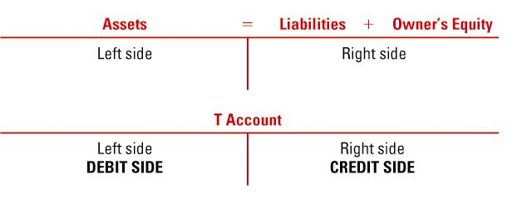
- A ___________________ is an accounting device used to ______________ transactions.

- ____________ an amount recorded on the ________ side.
- ____________ an amount recorded on the ________ side

- Account balances increase on the _______________ __________________ side of the account
- Account balances decrease on the side __________________ the normal balance side of an account
- Increases and decreases to asset accounts: Please label each T-account as seen in the PowerPoint by indicating increase, decrease, and normal balance.

- Increases and decreases in liability accounts:

- Increases and decreases in owner’s equity accounts.

Summary: (2 bullet points summarizing the main ideas or topics presented in class today. These should be at least four words each)

