Name: ______________________________________ Period: _____
2-2: Analyzing How Transactions Affect Accounts

- Each T-account has a _______________ (left side) and a _______________ (right side).
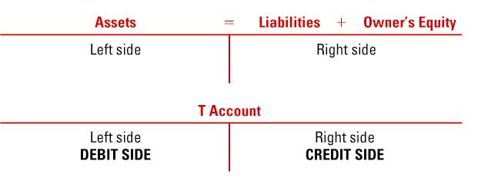

- There are always _______ actions in every transaction
- You will only have ______ debit and ______ credit for each transaction
- Always list your ___________ amount ______________, then ______________ amount _____________.

