Name: __________________________________ Period: ______
2-3: Analyzing How Transactions Affect Owner’s Equity Accounts

- In chapter 1, we labeled the account title capital as “revenue” anytime we made a sale.
- Now we will use the account title “_____________” anytime a sale is made.
  - Sales is a revenue account
  - Owner’s equity is still increased as a credit
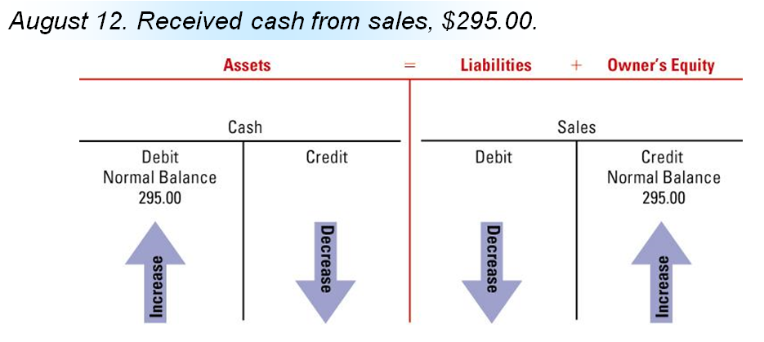

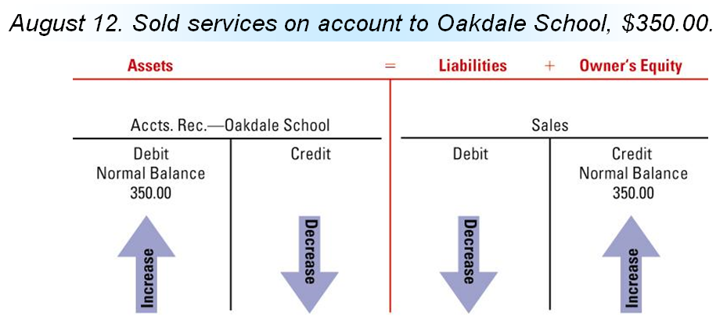

- _________ __________________ will be the account title used to record all payments for rent
  - This is a capital account
  - Any expense account decreases owner’s equity

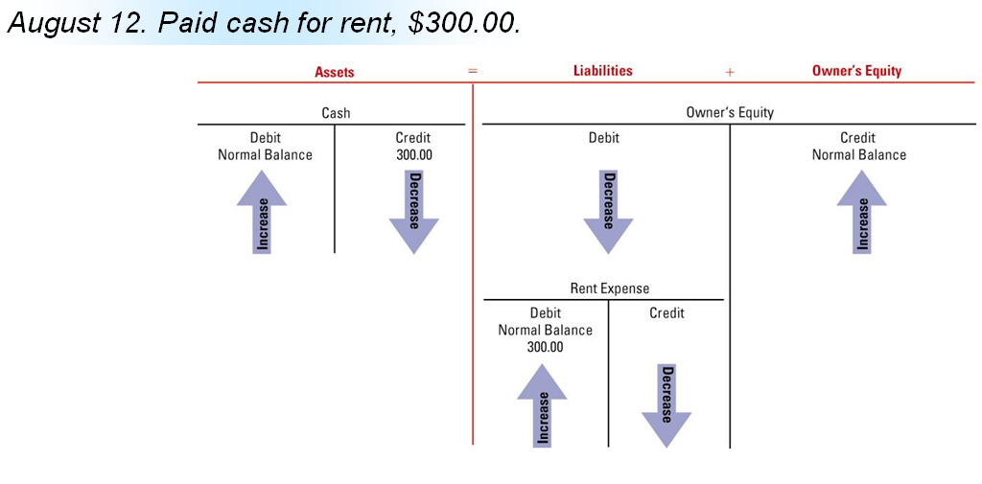

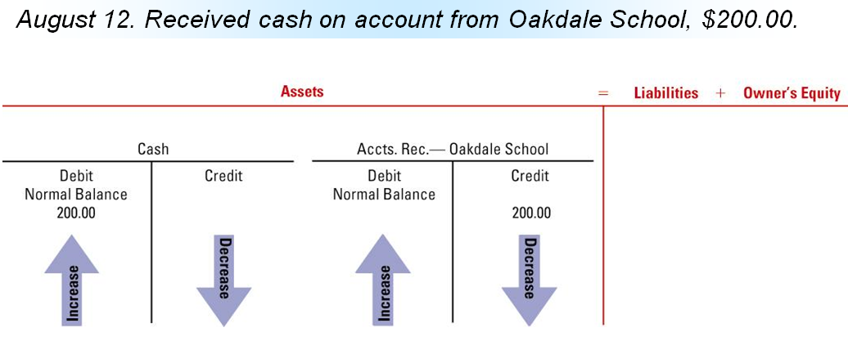

- Withdrawals are recorded using the account title _________________________.
  - Drawing is a capital account
  - All withdrawals decrease owner’s equity

