Name: __________________________________ Period: _____
3-1: Journalizing Entries in the General Journal
This packet will be used for sections 3-1, 3-2, 3-3, and 3-4

- A __________________ is a form that’s used to record transactions in _______________________ order.
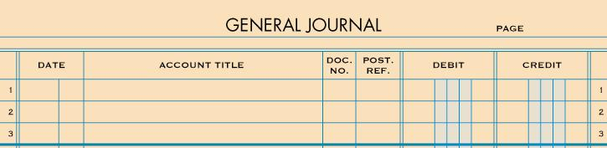

- Every transaction that is journalized MUST have ______________ that it exists to verify for accuracy.
- A ______________ _____________________ is a form which information is obtained from to journalize a transaction
- A transaction cannot be journalized without a source document to support it.
- Source document abbreviations:

- A _______________ is used for making ______________ payments and orders a bank to pay (debit) cash from a bank account.
- Each check is prenumbered to account for all checks.
- A ______________ ______________________ is used to record a sale _____ ____________________.
- Each sales invoice is prenumbered to account for all invoices.
- A ___________________ is written acknowledgment for cash received regarding transactions other than sales
- A ________________ is a form in which a brief message is written on describing a transaction when no other source document can be used
- A ________________________ _______________ is used to total the amount of cash received from sales for each day.
- Each tape is numbered with each day’s date.

- Four steps to journalizing a transaction:
  - ____________________________________________________________________________________________________________________________________
  - ____________________________________________________________________________________________________________________________________
  - ____________________________________________________________________________________________________________________________________
  - ____________________________________________________________________________________________________________________________________
