Name: _______________________________ Period: ____

4-1: Creating a Chart of Accounts

- A general ledger is a ledger that contains all account needed to prepare financial statements
- Each account has an account title and an account number. An account number is a number assigned to an account.

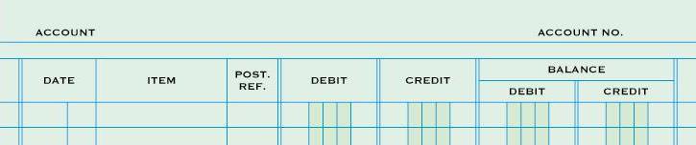

Chart of Accounts

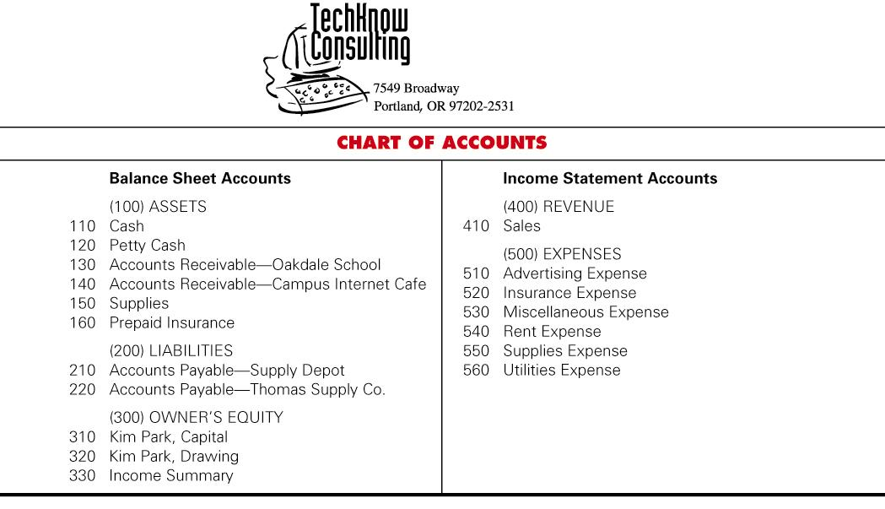

Assigning Account Numbers

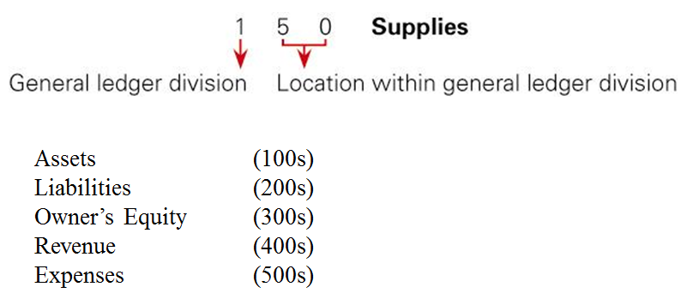

- Assets are listed by order of their ______________. How readily they can be converted to cash
  - Cash, A/R, Supplies, Prepaid Insurance,
- A/R are ordered ________________________ using the first initial of a company customer and the first initial of the last name of an individual customer

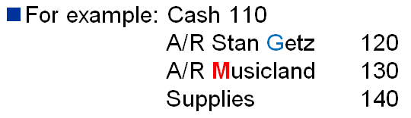

- All other items are listed _________________________________
- A/P follows the same ordering rules as A/R
- Alphabetized by the first initial of the last name of an individual vendor or the first initial of the name of company vendor

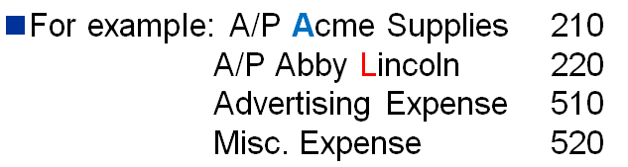

- New numbers can be assigned between ______________ account numbers without renumbering all existing accounts
- A new account is assigned the middle, unused account number between the numbers of existing accounts.

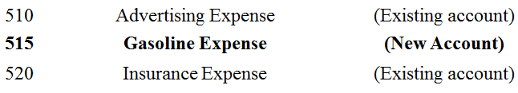

- Make sure there’s enough extra account numbers above and below a new account in-case new accounts are later added
- Expenses and names of people are arranged in _______________________ order
- When an account number is no longer needed, that number then becomes available for another account if needed
- When an account is added at the end of a ledger division, the next number in a sequence of 10’s is used
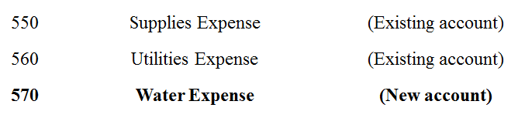

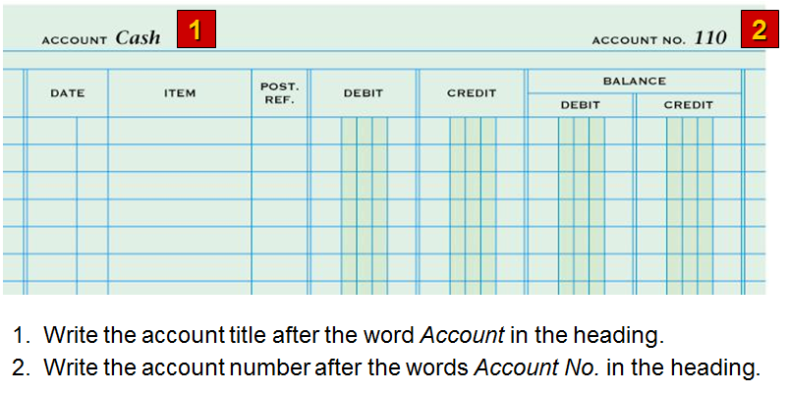

- The procedure for arranging accounts in a general ledger, assigning account numbers, and keeping records current is _____________ __________________________.

