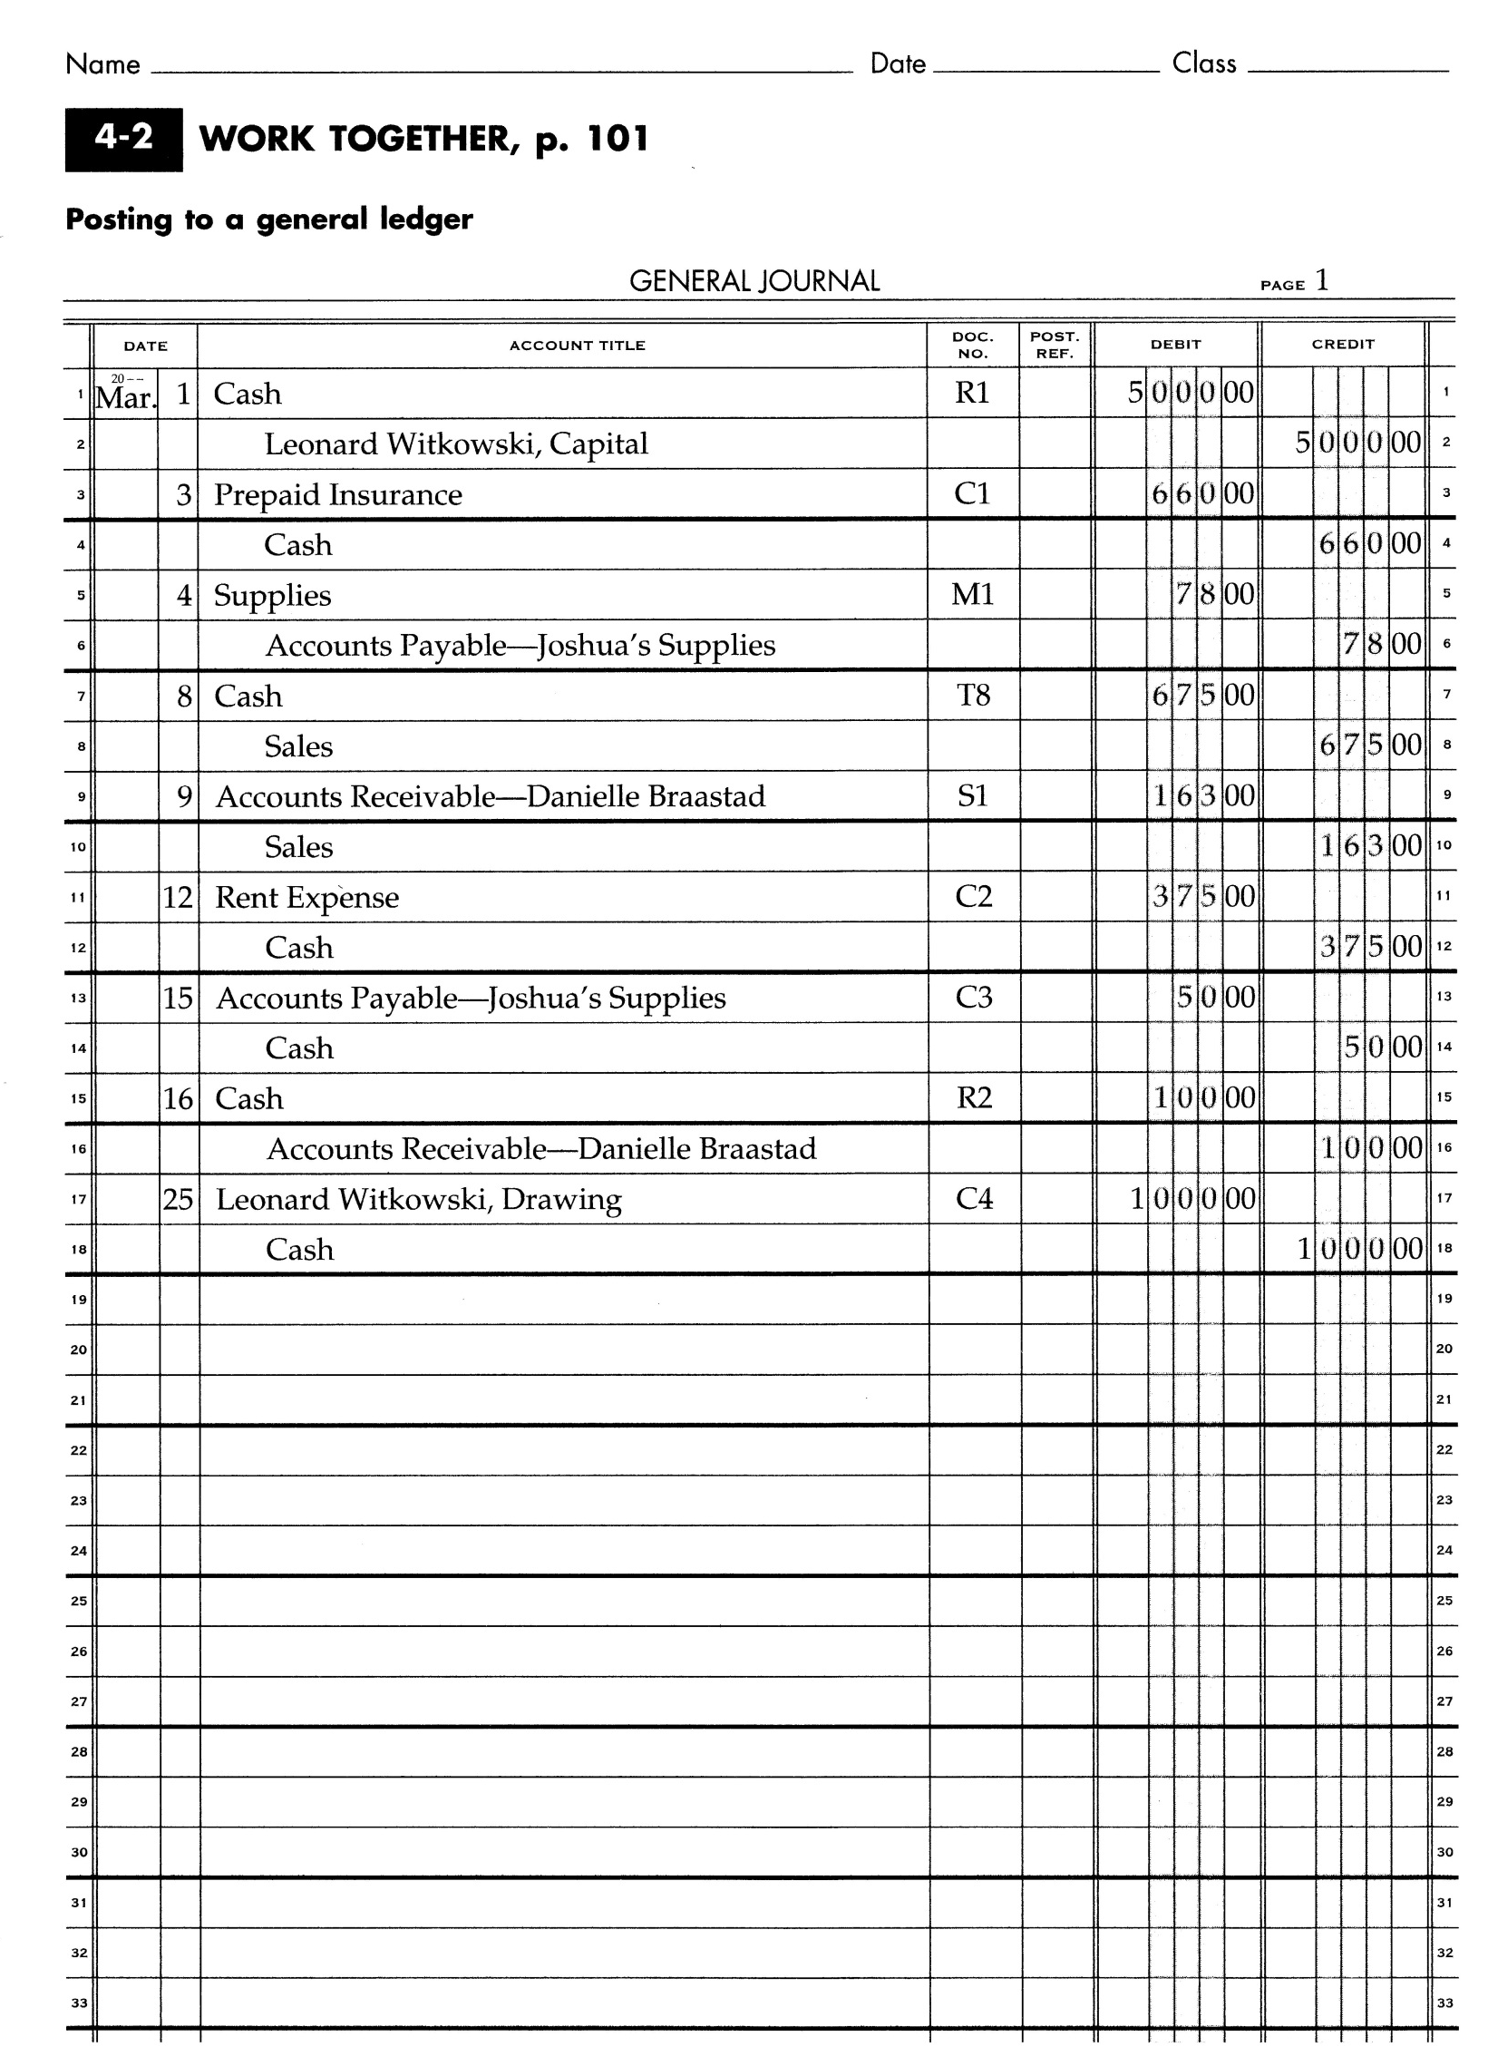

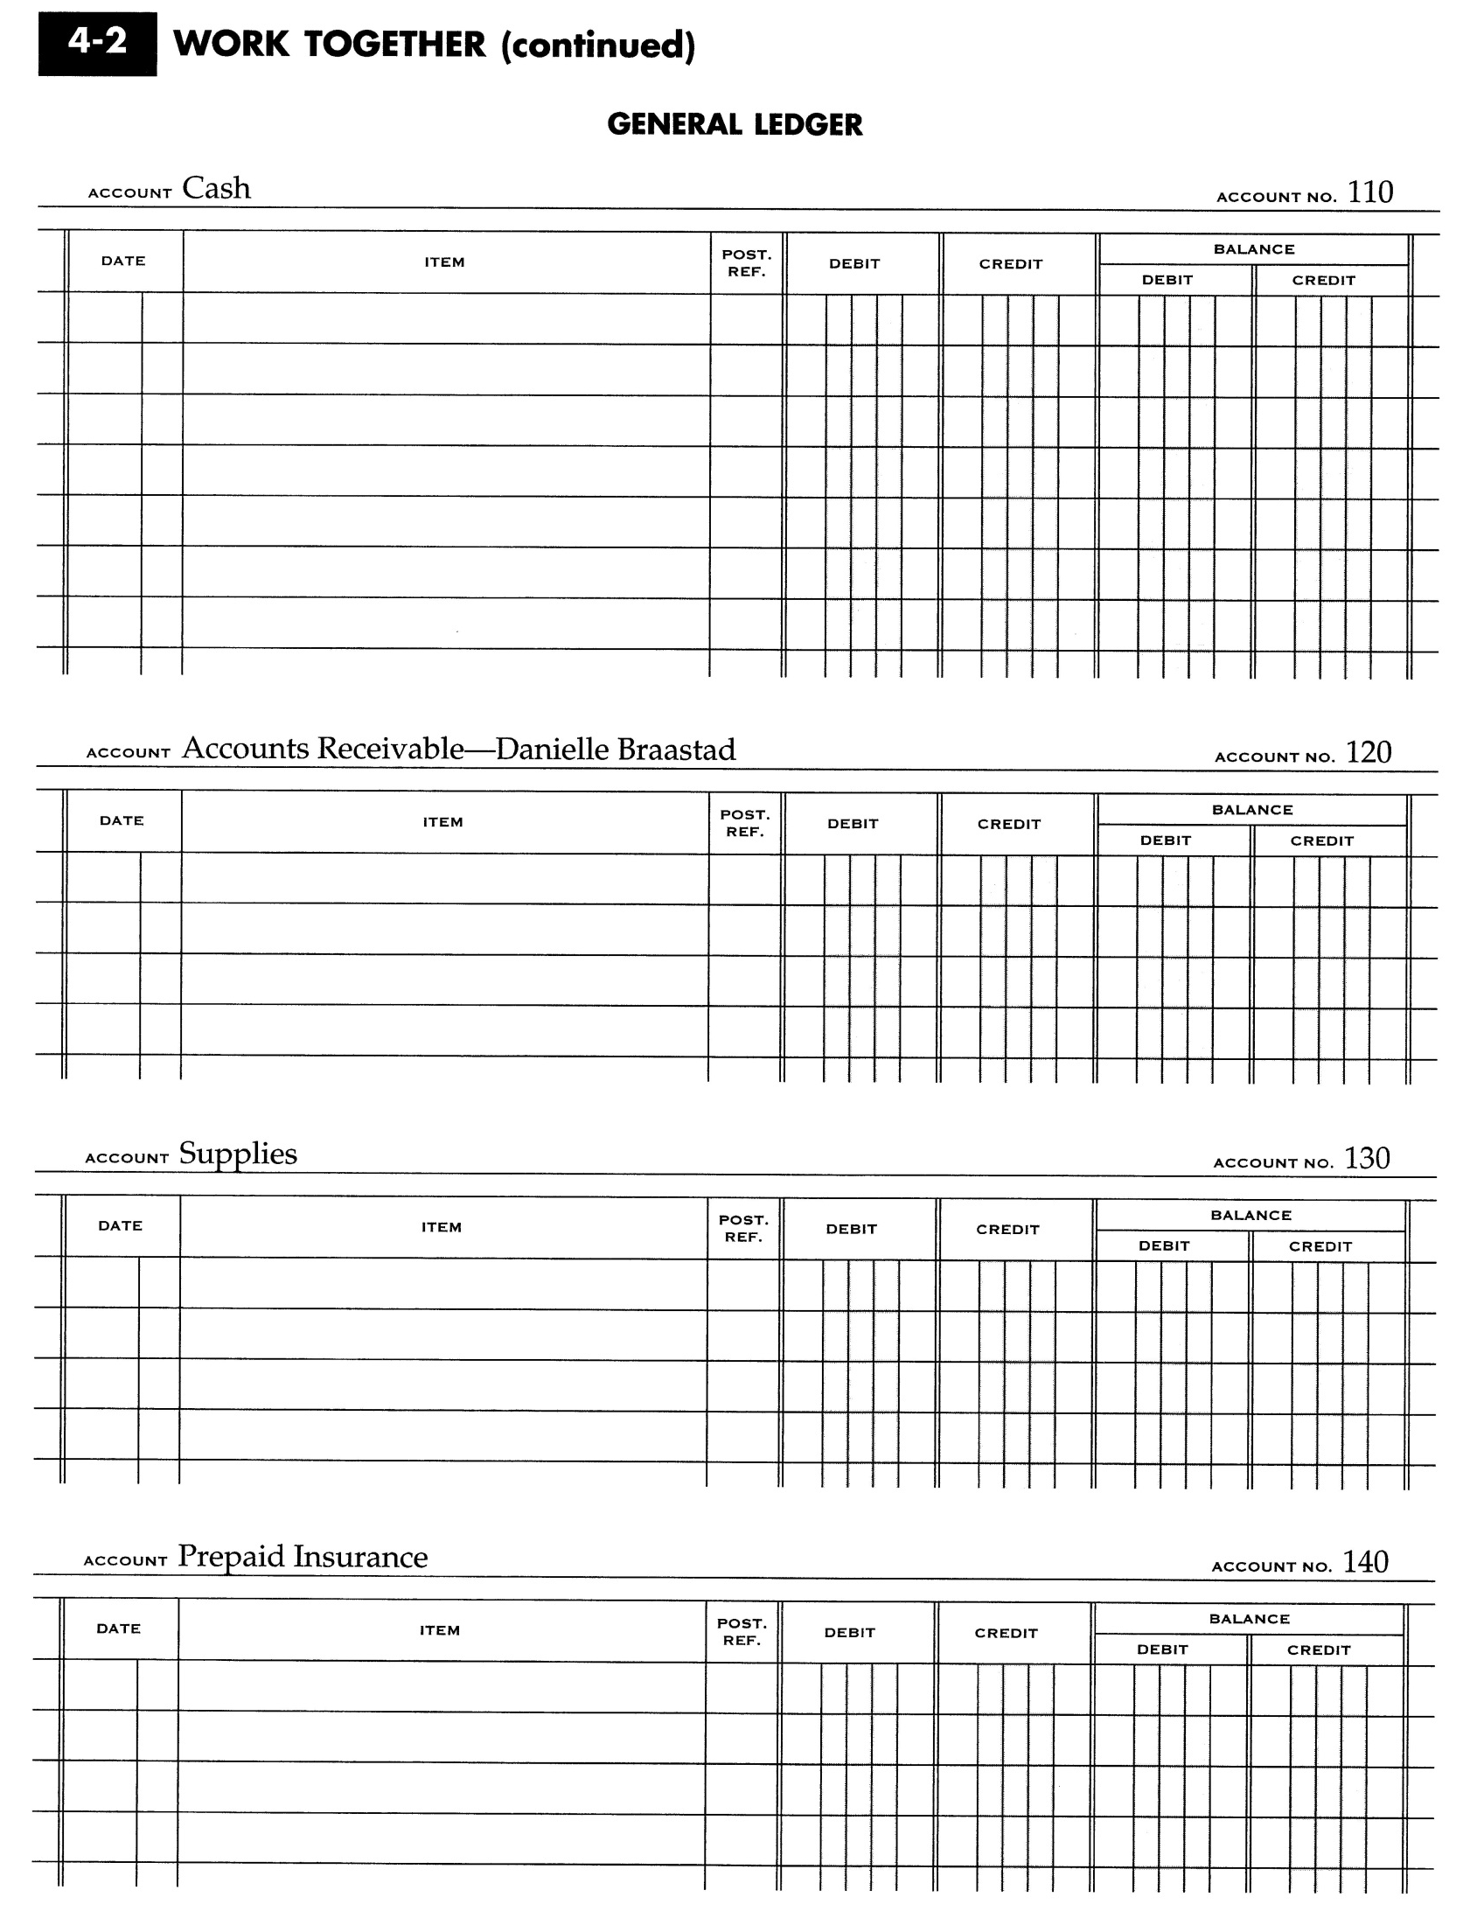

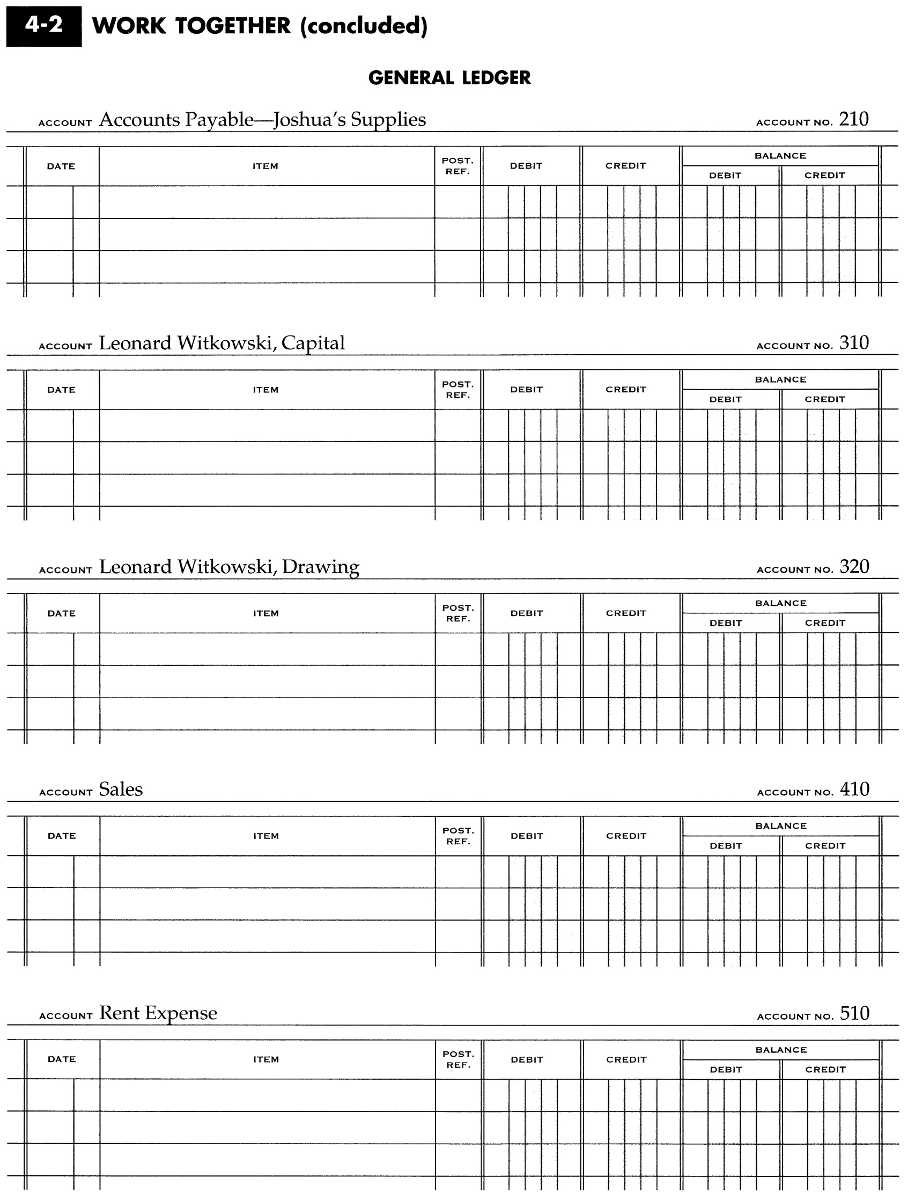

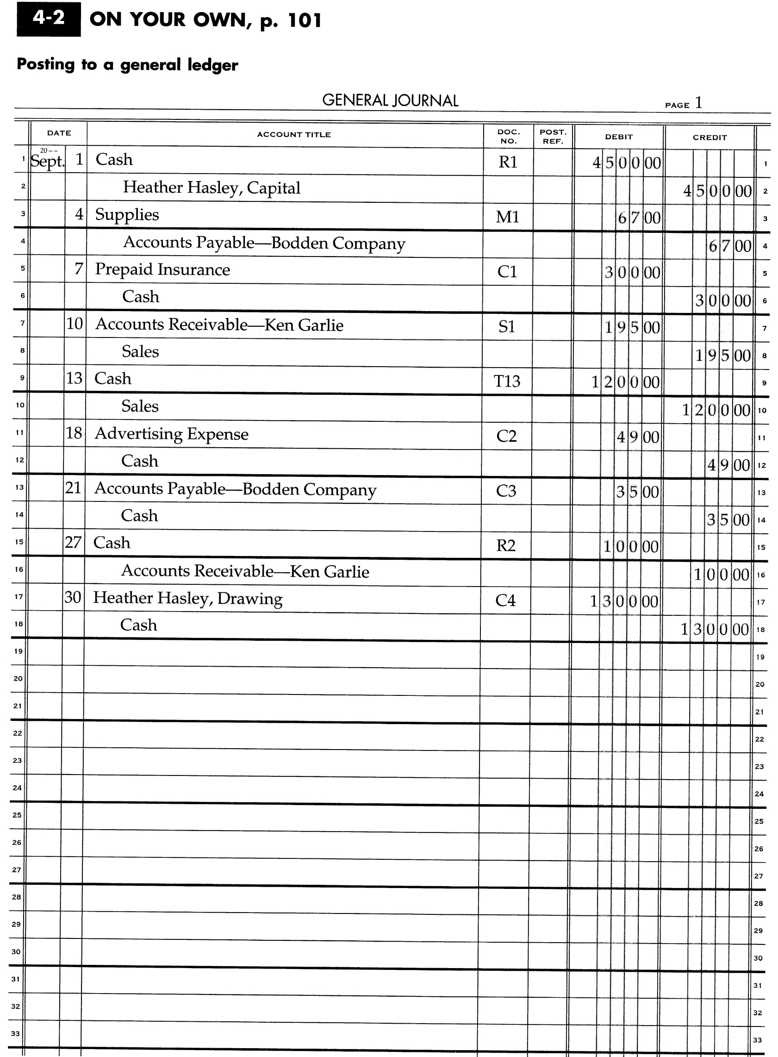

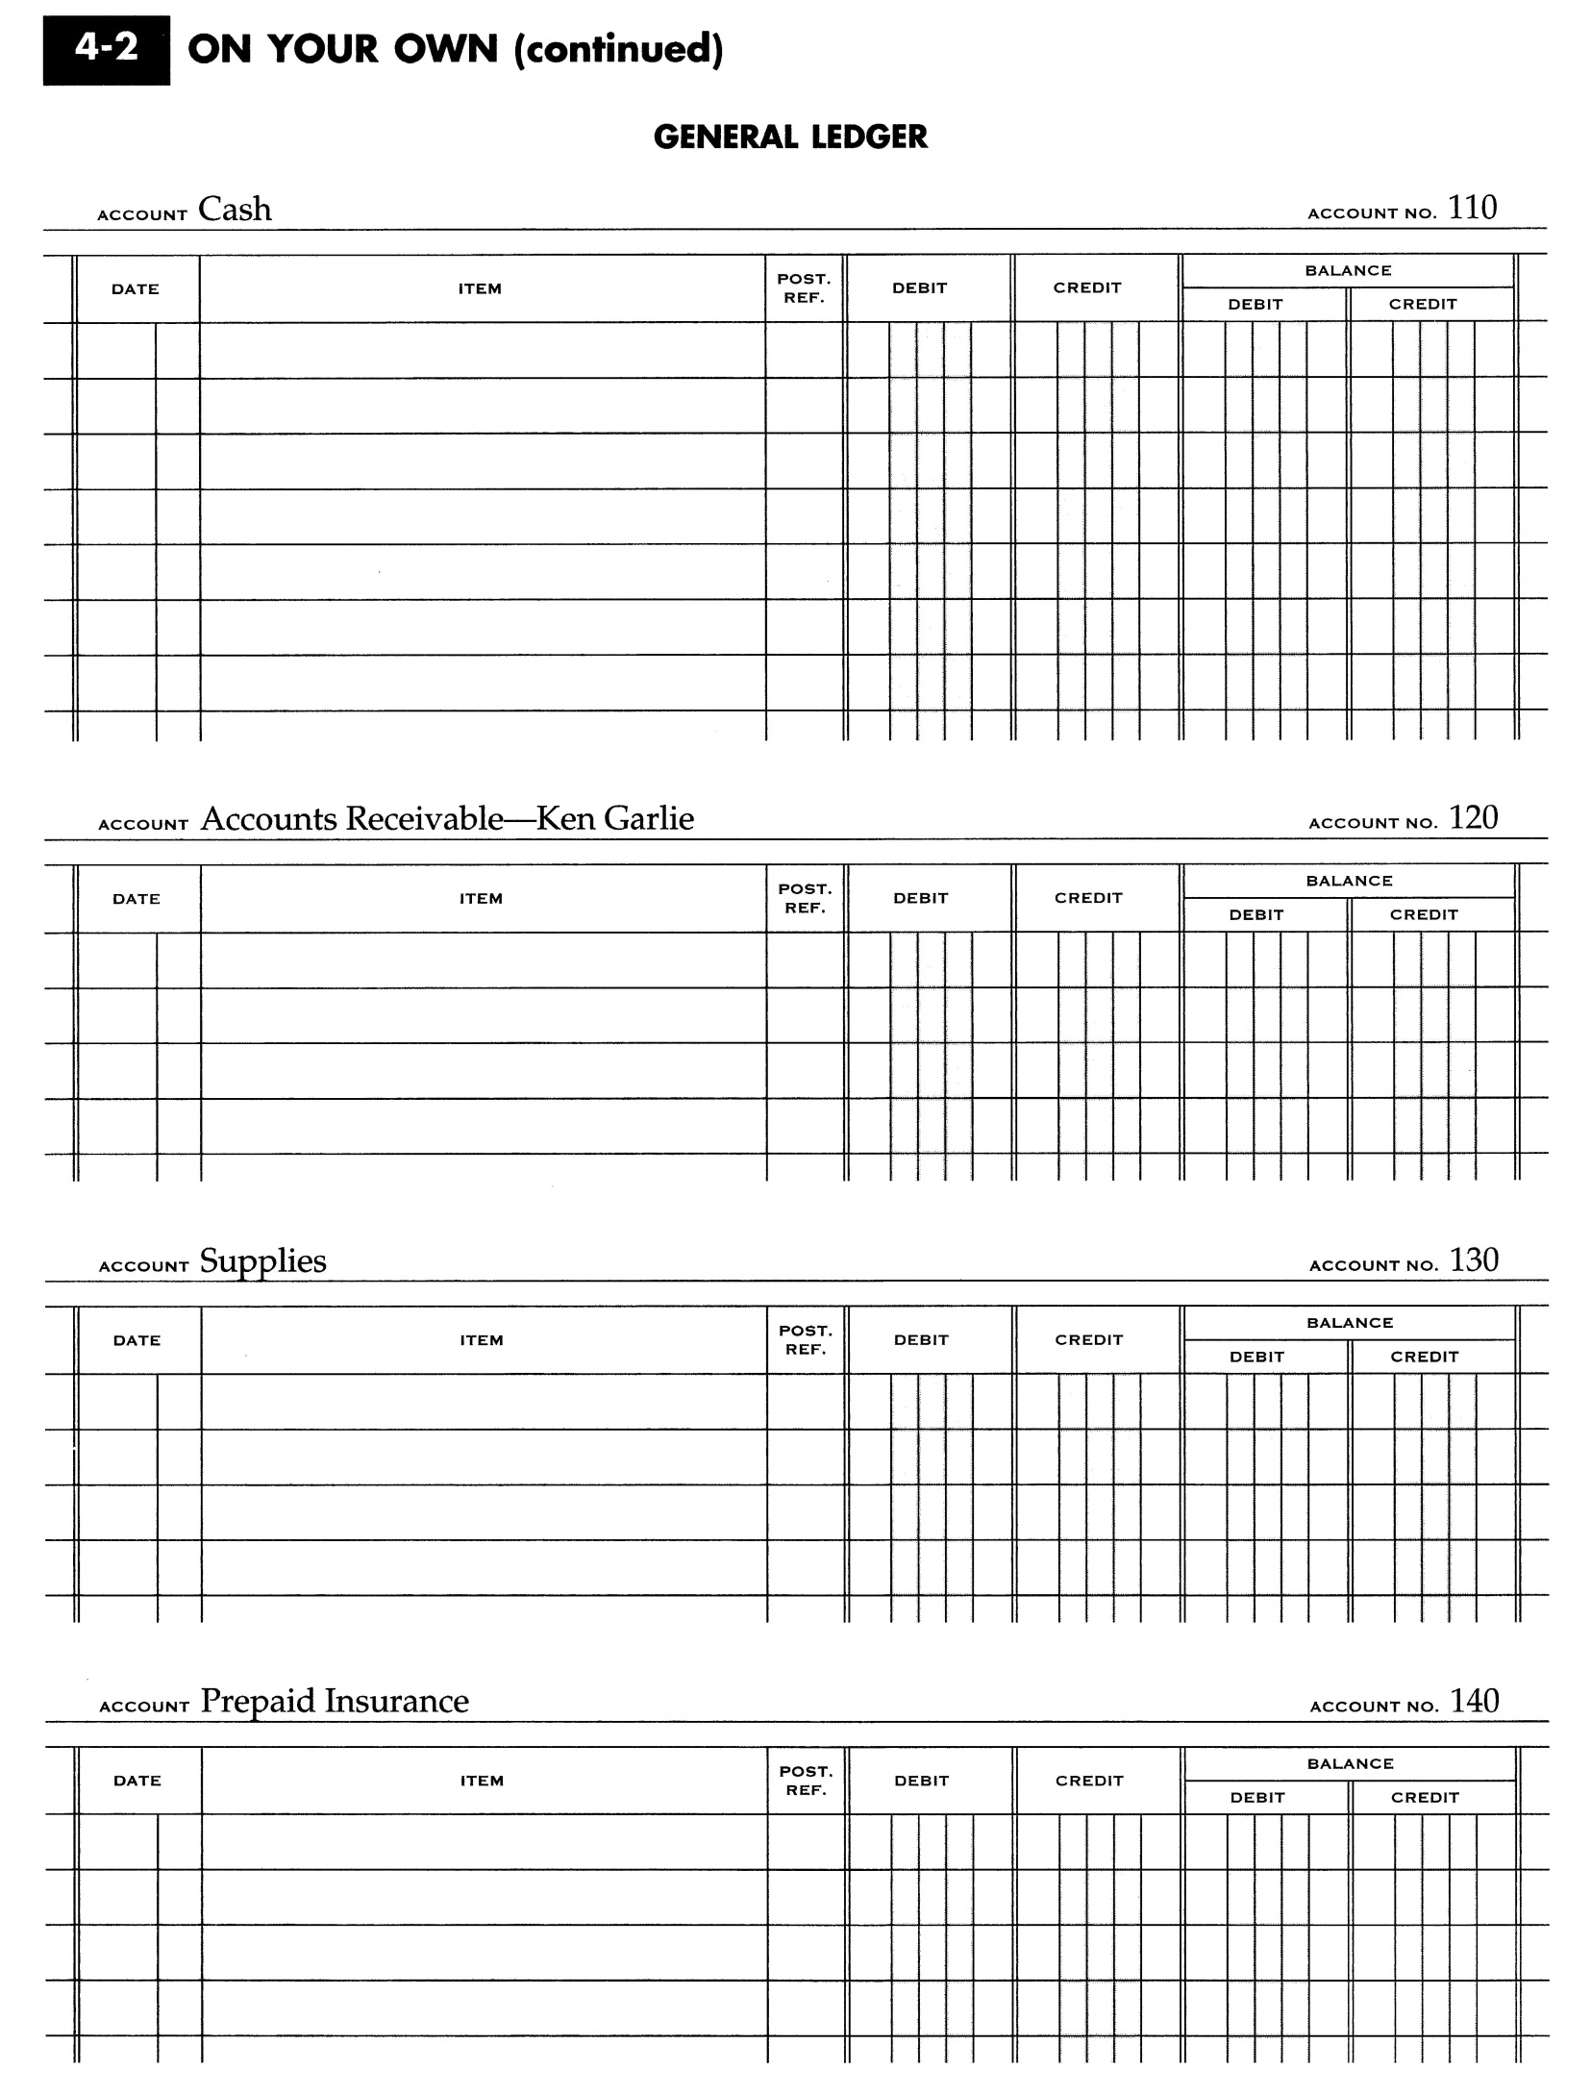

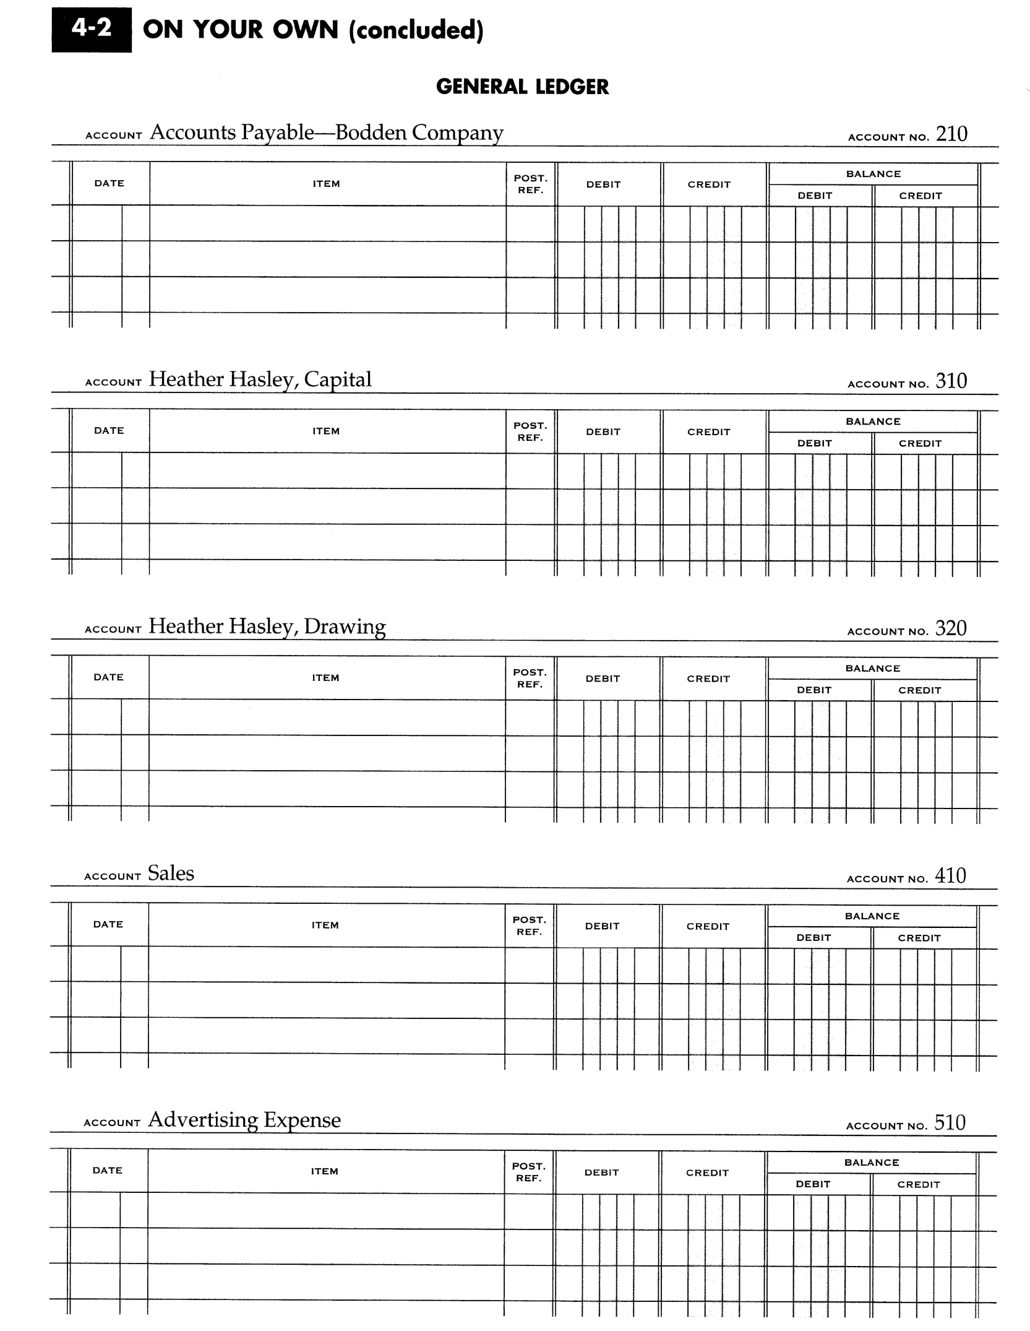

- The five steps for posting to a General Ledger:
  - ________________________________________________________________________________________________________________________________________________
  - ________________________________________________________________________________________________________________________________________________
  - ________________________________________________________________________________________________________________________________________________
  - ________________________________________________________________________________________________________________________________________________
  - ________________________________________________________________________________________________________________________________________________
- Transferring information from a journal entry to a ledger account is called _________________.
- A blank Post. Ref. column means that posting for that line _______________ _______________ ______ ______ ______________________________. This is always the last step of the posting process.
- Whenever the debits in an account exceed the credits, the balance is a ______________.
- Whenever the credits in an account exceed the debits, the balance is a ______________.
