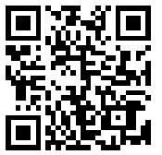
Name: __________________________________ Period: ____

Type of Business Ownership 4.1

- Would you prefer to start your own business or purchase an existing business? Why?

- What are advantages of stating your own business from scratch, and advantages of purchasing an existing business?

Advantages of Starting Your Own | Advantages of Purchasing an Existing Business

- What are disadvantages of stating your own business from scratch, and disadvantages of purchasing an existing business?

Disadvantages of Starting Your Own | Disadvantages of Purchasing an Existing Business
- When purchasing an existing business, do you feel it’s important to know why the business is for sale or why the owner is selling?

- What are some reasons why you think business owners may sell their business?

