Name: ___________________________________ Period: _____

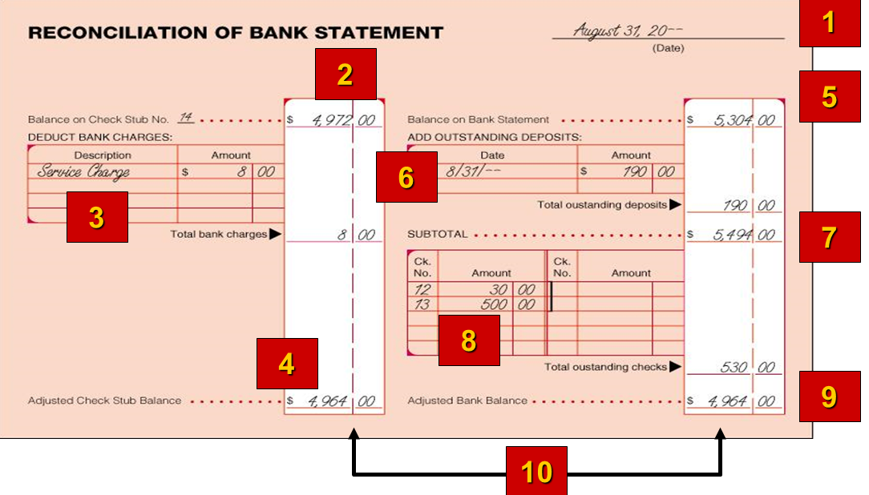5-2: Bank Account Reconciliation

