Name: _____________________________________ Period: ______

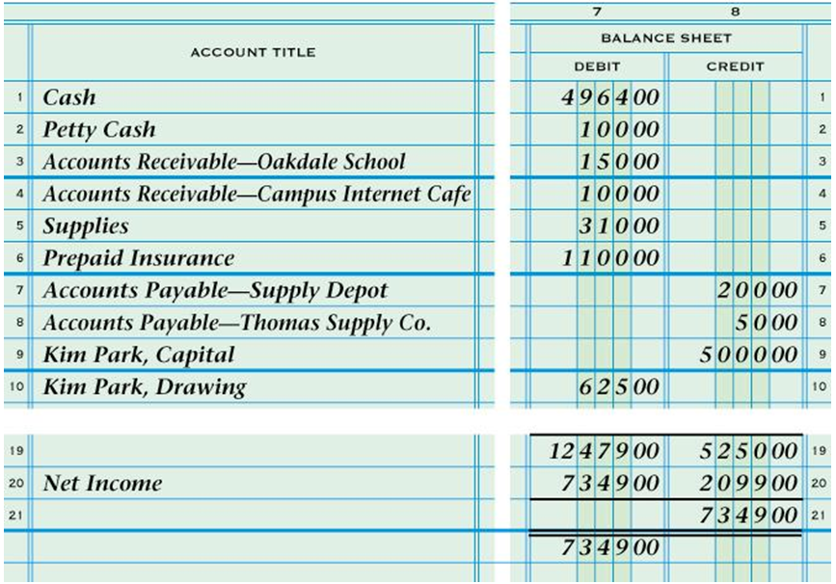**7-2 NOTES**

|  |  |  |  |  |  |  |
| --- | --- | --- | --- | --- | --- | --- |
| **Capital Account Balance** | **+** | **Net Income** | **-** | **Drawing Account Balance** | **=** | **Current Capital** |

