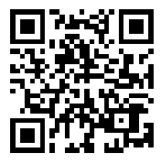
Name: ___________________________________ Period _____
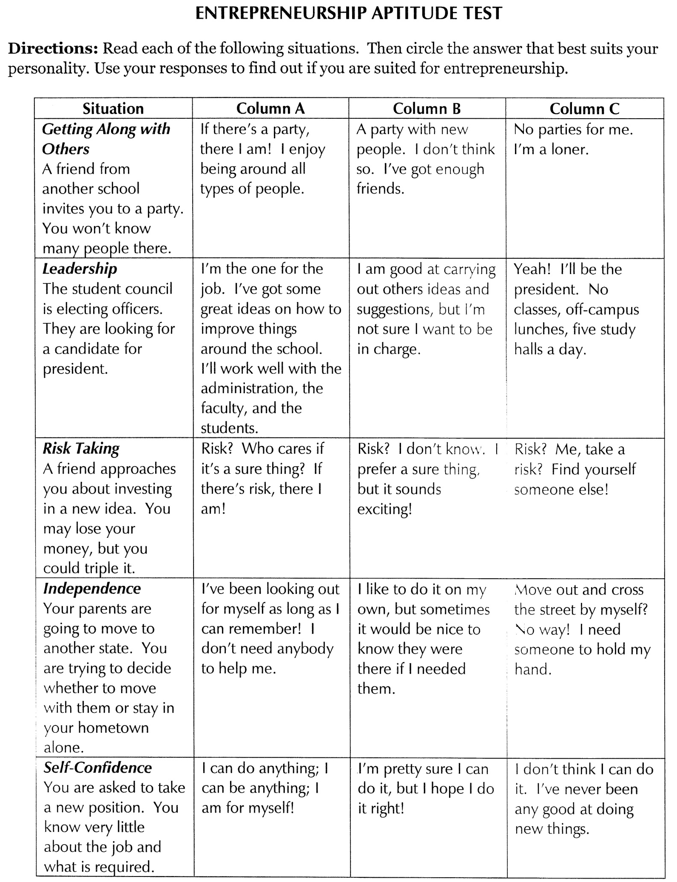

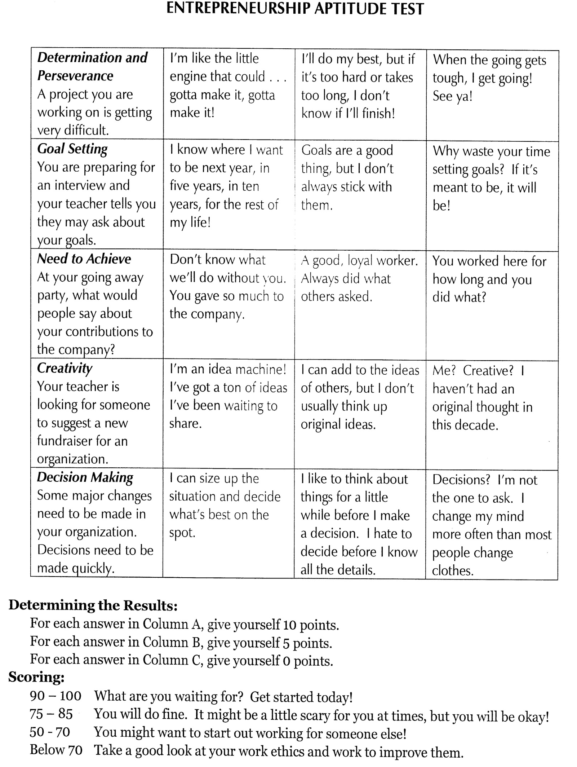

An entrepreneur is someone who undertakes the creation and ownership of a business.
What are 5 current trends in our economy and in the marketplace that can provide opportunities for entrepreneurs? What opportunities do these trends provide to entrepreneurs?
Some trend ideas can include: Speed, convenience, experience, technology, Internet, efficiency, social media, options, etc.
Trends: | Opportunities for Entrepreneurs:

Name one entrepreneur that has inspired you based on their accomplishments:
_________________________________
What has this entrepreneur accomplished that inspired you to select him/her?
_______________________________________________________________________________________________________________________________________________________________________________________________________________________________________________________________
What business or product idea can you see yourself pursuing as a result of having been inspired by your selected entrepreneur? Why did you select this business or product idea? ____________________________________________________________________________________________________________________________________________________________________________________________________________________________________________________________________________________________________________________________________________________

List one product that you use frequently: __________________________________________________
List three different places (online or brick-and-mortar) that you can purchase the same product from:
- _________________________________________________
- _________________________________________________
- _________________________________________________
Compare the price, availability, selection, convenience and customer service offered at each place. Explain your answers.
- Price: Which place offers the cheapest price and which offers the most expensive price? ____________________________________________________________________________________________________________________________________________________________
- Availability: Which place can you rely on the most to always have your product in stock? Which place can you rely on the least? ____________________________________________________________________________________________________________________________________________________________
- Selection: Which place offers the most options and selection with your product? Which place offers you the fewest options and selections for your product? ____________________________________________________________________________________________________________________________________________________________
- Convenience: Which place is the most convenient for you to shop at? Which place is the least convenient for you to shop at? ____________________________________________________________________________________________________________________________________________________________
- Customer service: Which place offers the you the best customer service experience where you purchase your product at? Which place offers you the least customer service experience where you purchase your product at? ____________________________________________________________________________________________________________________________________________________________

