Name: ___________________________________ Period: _____

Business Plan Common Mistakes

Directions: Today you will be navigating a new website called bplans.com to view sample business plans and to learn from the mistakes that other entrepreneurs have made in the past.

Enter the following link into your Internet browser: http://www.bplans.com and click on Common Business Plan Mistakes as seen in the box below.

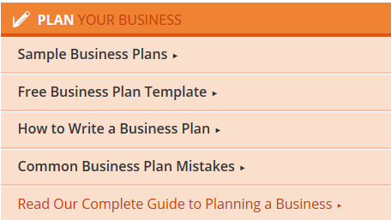

Common Business Plan Mistakes:

- Putting it off: “Too many businesses make business plans only when they have no choice in the matter.” What does this mean?

- Cash flow casualness: Why is understanding cash flow critical?

- Idea Inflation: “You don’t need a great idea to start a business…” What four items do you need?

- Idea inflation: “Few successful businesses are based entirely on new ideas. A new idea is harder to sell than an existing one.” Why is a new idea harder to sell than an existing one?

- Spongy, vague goals: “Leave out the vague and the meaningless babble of business phrases (such as “being the best”)” Why should you do this?

- Diluted priorities: “A priority list with 20 items is certainly not strategic, and rarely if ever effective.” What happens if you have more than 20 items?
Next, click on Sample Business Plans. Search through the list of free sample business plans to see if there are any businesses that resemble your own business idea. Take a look to see what is included in these samples and what idea you could include in your own business plan.

List THREE items or ideas that you found in the sample business plans that you feel are necessary to include in your own business plan:

- ________________________________________________________________________________________________________________________________________________________________________________________________________________________

- ________________________________________________________________________________________________________________________________________________________________________________________________________________________

- ________________________________________________________________________________________________________________________________________________________________________________________________________________________

