Name: ___________________________________ Period: ______

PLEASE USE PENCIL

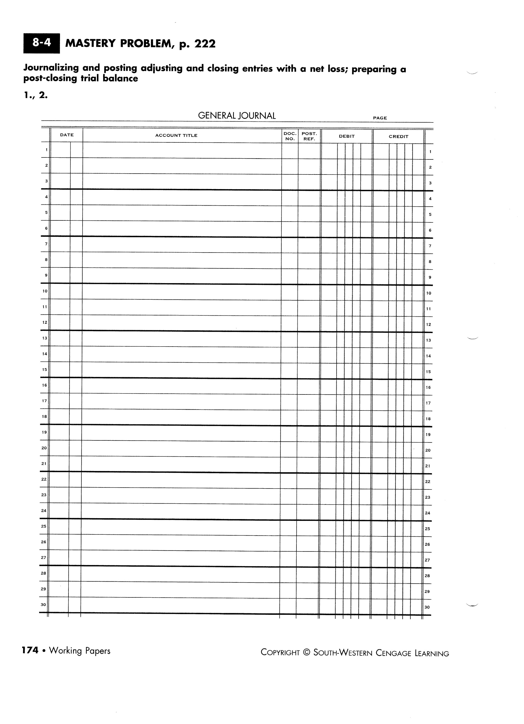

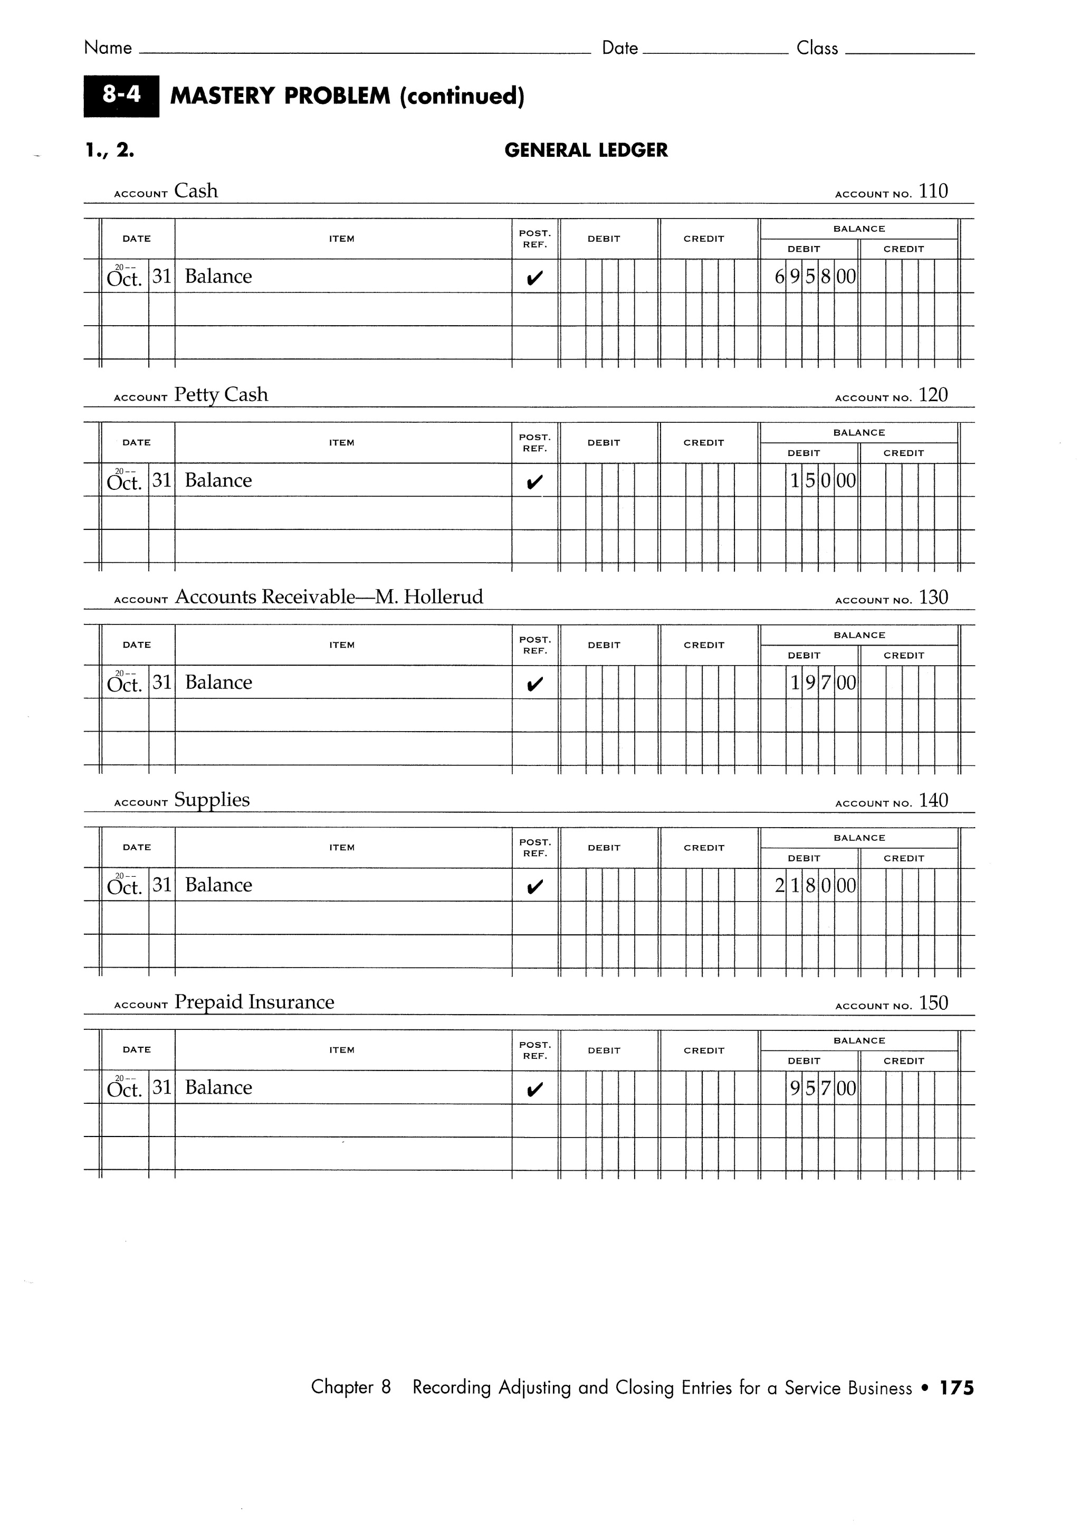

DON’T FORGET TO INCLUDE PAGE NUMBERS

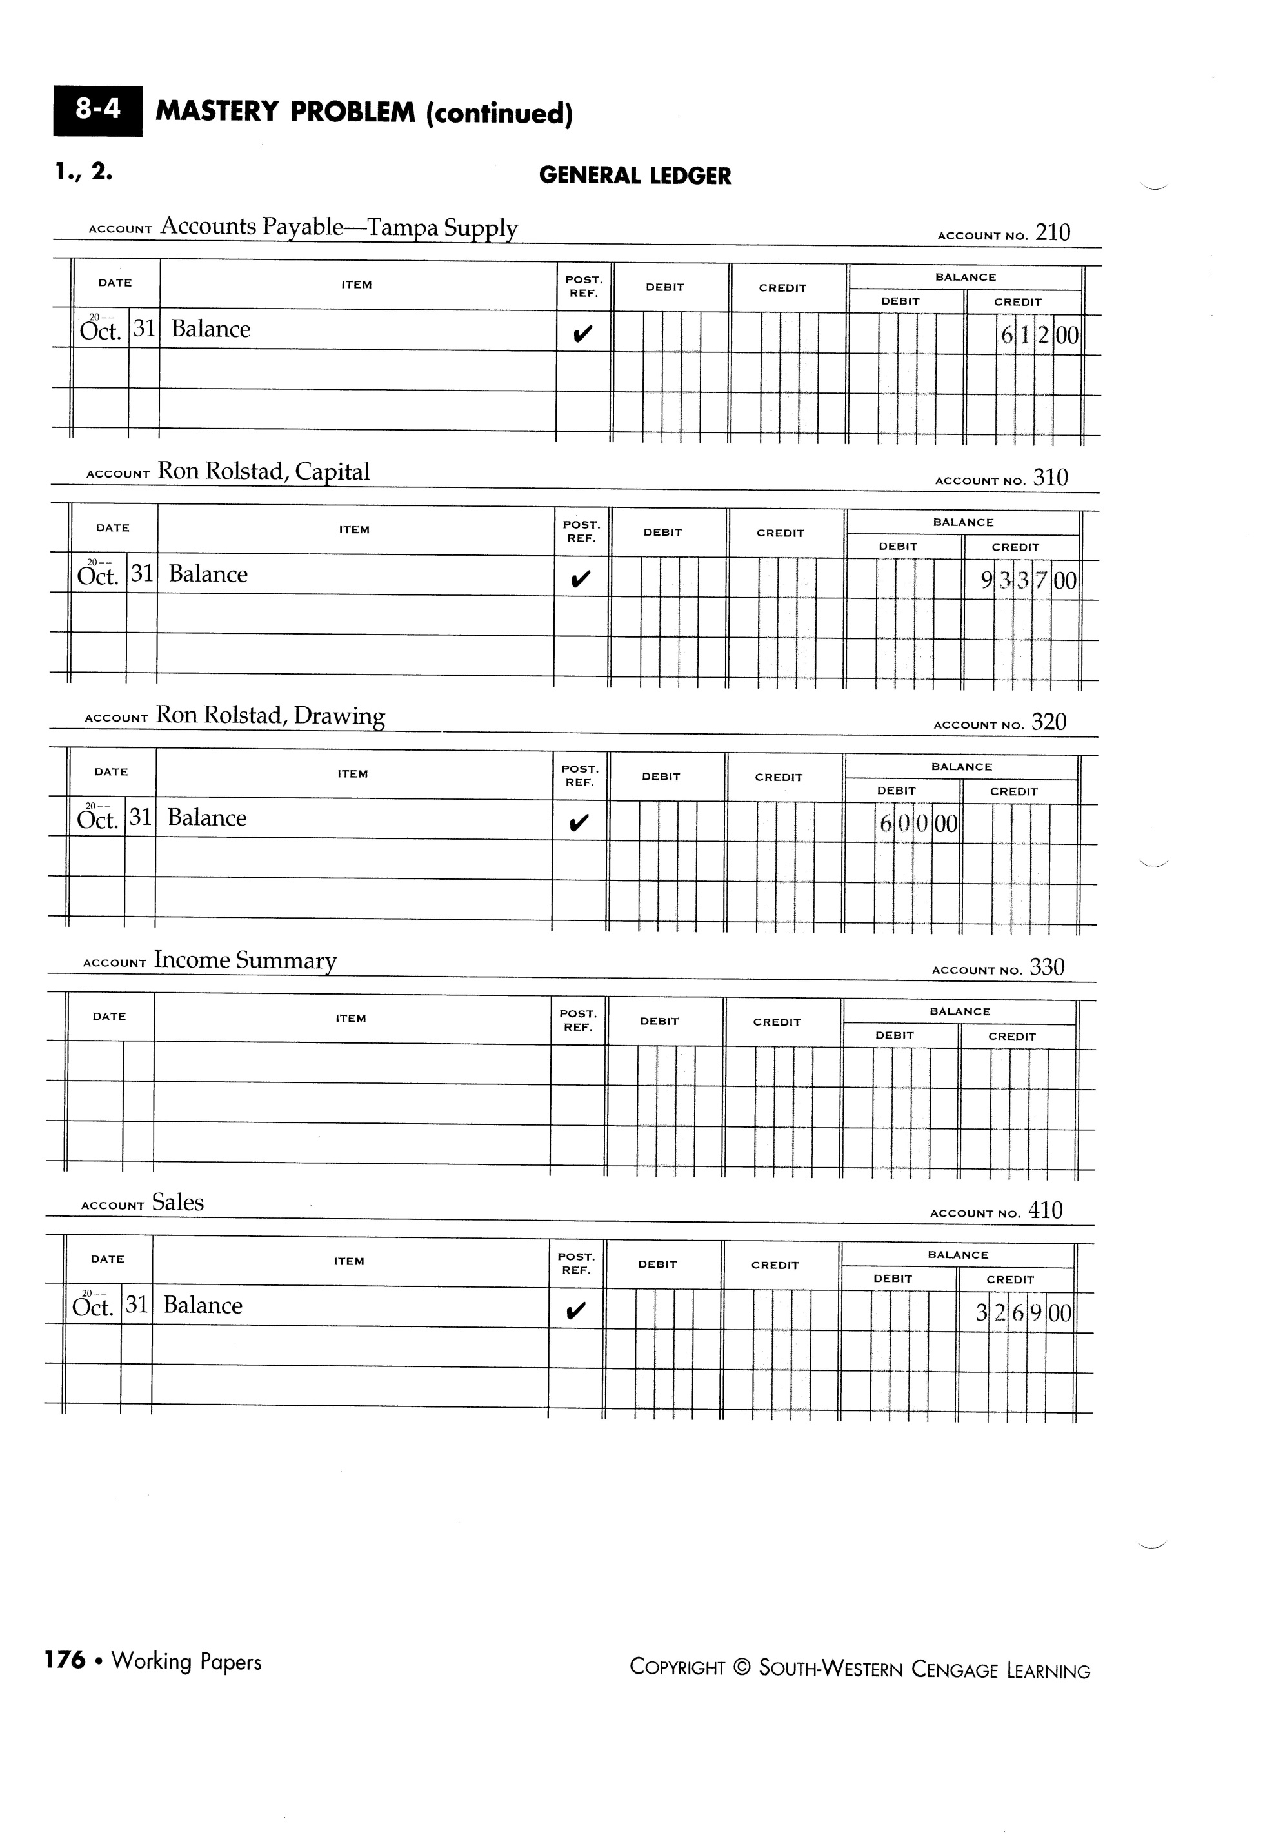

DON’T FORGET TO INCLUDE PAGE NUMBERS

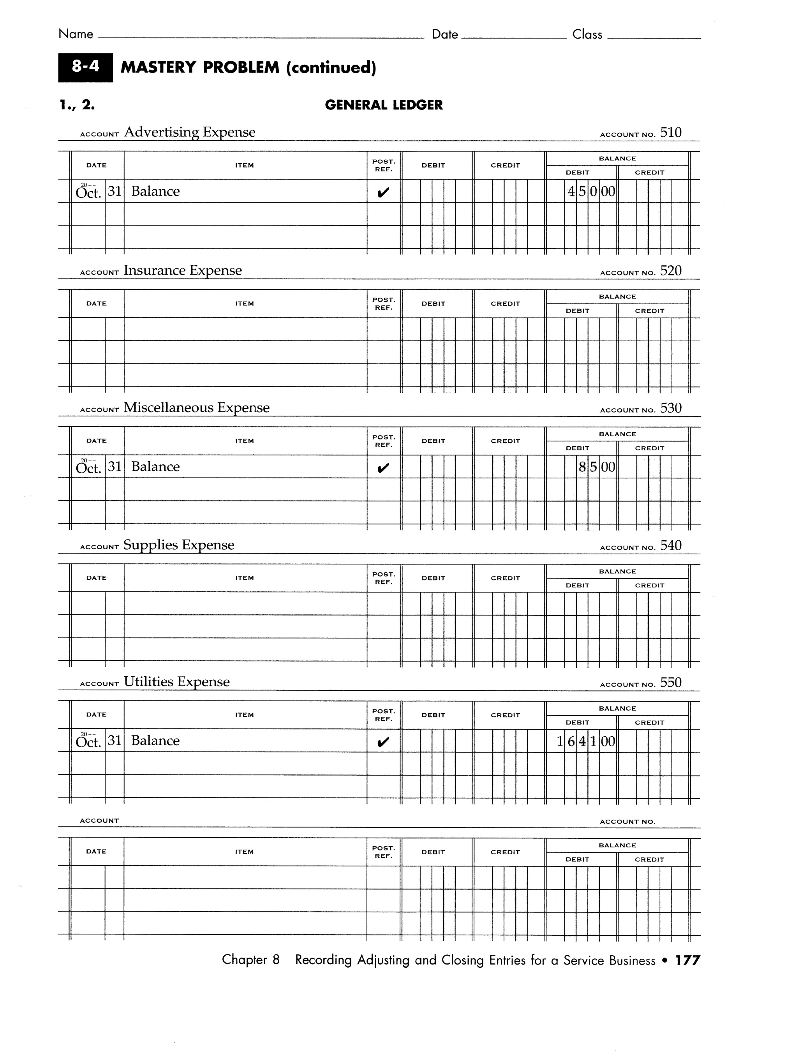

DON’T FORGET TO INCLUDE PAGE NUMBERS

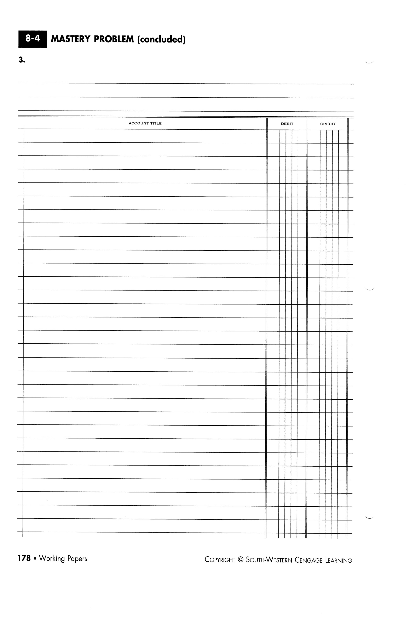

POST-CLOSING TRIAL BALANCE

MAKE SURE TO GO BACK TO THE FIRST PAGE AND INCLUDE ALL ACCOUNT NUMBERS IN THE POST REF. COLUMN