Name: __________________________________ Period: _____
Financial Aid Web Search
View this assignment at http://northbiz.weebly.com
Directions: Locate a school of your choice by accessing the link below. You will need to search for total annual cost, total in-state tuition, out-of-state tuition if applicable, and percent of students receiving scholarships.
http://cgi.money.cnn.com/tools/collegecost/collegecost.html
School name: _______________________________________ Location: ________________________
Total annual costs: __________________________________
In-state tuition/tuition: _______________________________
Out-of-state tuition: ______________________ Students receiving scholarships: ___________%

Directions: Now that you’re aware of the annual costs of your top school above, calculate the total cost of college over a two or four year period by using an online loan calculator. Leave tuition inflation at 7%. USE THE TOTAL COST FROM ABOVE.
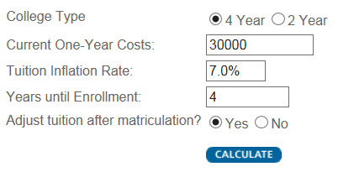
http://www.finaid.org/calculators/costprojector.phtml

EXAMPLE

School: ______________________________________________
First year projected costs: $_________________________
Second year projected costs: $_________________________
Third year projected costs: $_________________________
Fourth year projected costs: $_________________________
Total projected costs: $_________________________

Directions: Now that you’re aware of the costs of your top three schools, locate two unusual scholarships using the link below to help off-set the costs of tuition. You may search other websites of your own choosing if you aren’t satisfied with the unusual scholarships that are listed on the link.
http://www.finaid.org/scholarships/unusual.phtml
Name of scholarship: ___________________________________________________________________
Potential amount awarded: ___________________________
What makes this scholarship unusual and would you seriously apply? __________________________________________________________________________________________________________________________________________________________________________

Name of scholarship: ___________________________________________________________________
Potential amount awarded: ___________________________
What makes this scholarship unusual and would you seriously apply? __________________________________________________________________________________________________________________________________________________________________________

Directions: Access the LEAF website by entering the link below. Search for one scholarship available to students attending Eastlake North High School.
http://scholarship.leaf-ohio.org/
Name of scholarship: ___________________________________________________________________
Deadline: ________________________________ Award: $________________________________
Why did you select this scholarship/what interested you? __________________________________________________________________________________________________________________________________________________________________________

