Name: ____________________________________________ Period: _______

BUSINESS FLOOR PLAN

Directions: You are to create a floor plan for your business below. Even if your business is entirely online, you will still need a floor plan for your warehouse and offices. Floor plans should be DETAILED. Use the examples on the back to see how detailed your plan should be. Be sure to label where significant furniture should be placed, exits, windows, office space, store rooms, etc.

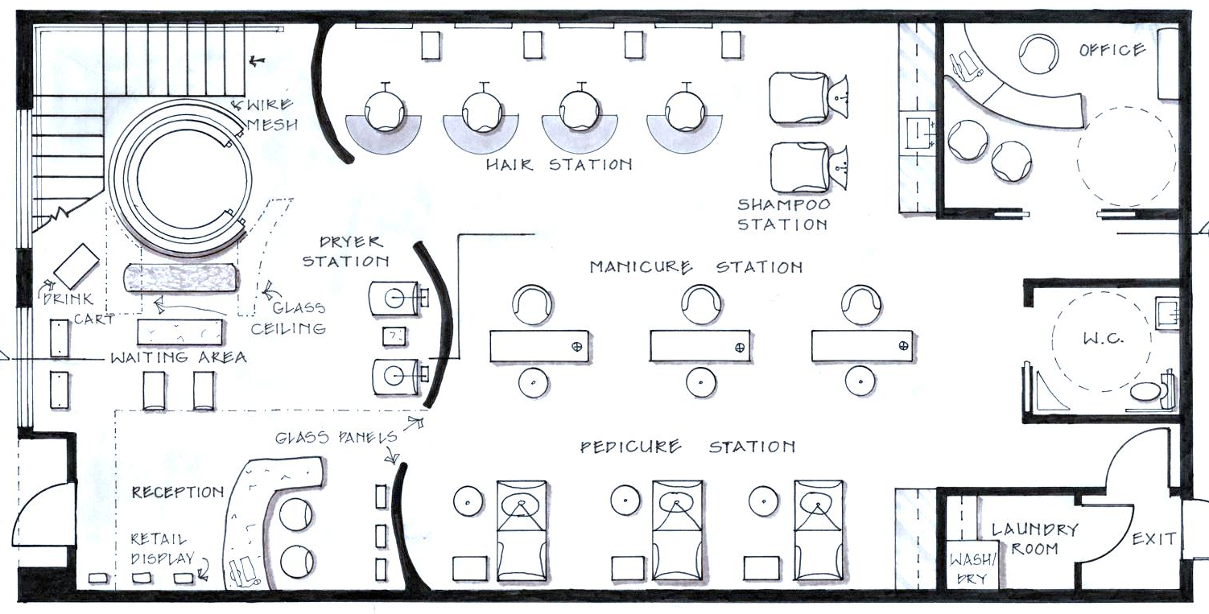
SALON FLOOR PLAN
RESTAURANT FLOOR PLAN

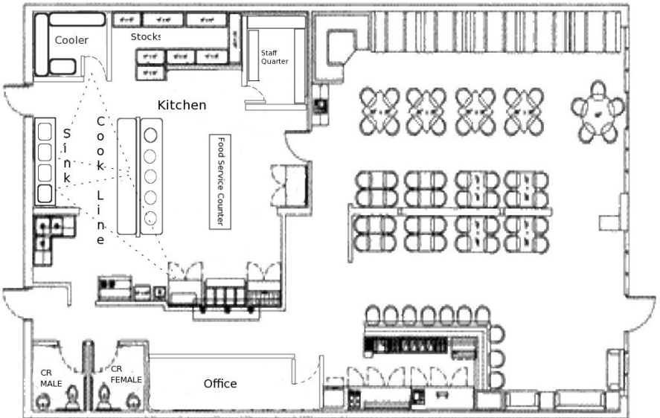

ONLINE BUSINESS / OFFICE FLOOR PLAN

