Name: ________________________________________ Period: ____

Grand Opening Advertisement

Directions: You will create a postcard advertisement to be mailed to households in your business’s community. The ad must be professional looking and ready to mail out. You will be running the advertisement for the first month of your business. You should consider including the location of your business, website address, merchandise or services that you are selling, grand opening discounts, business logo, etc.

Top

SAMPLE ADS

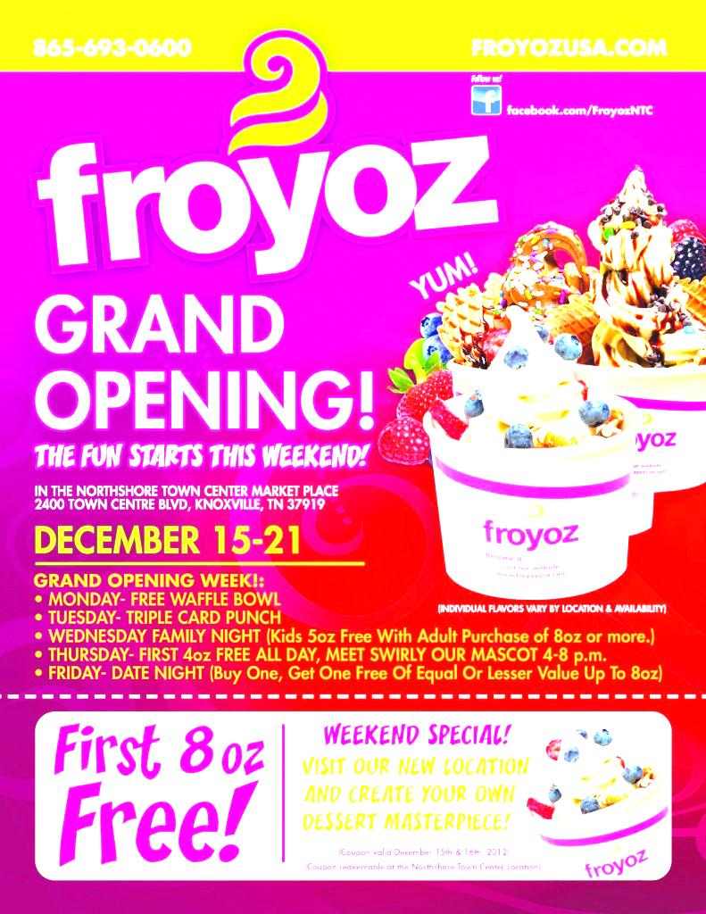
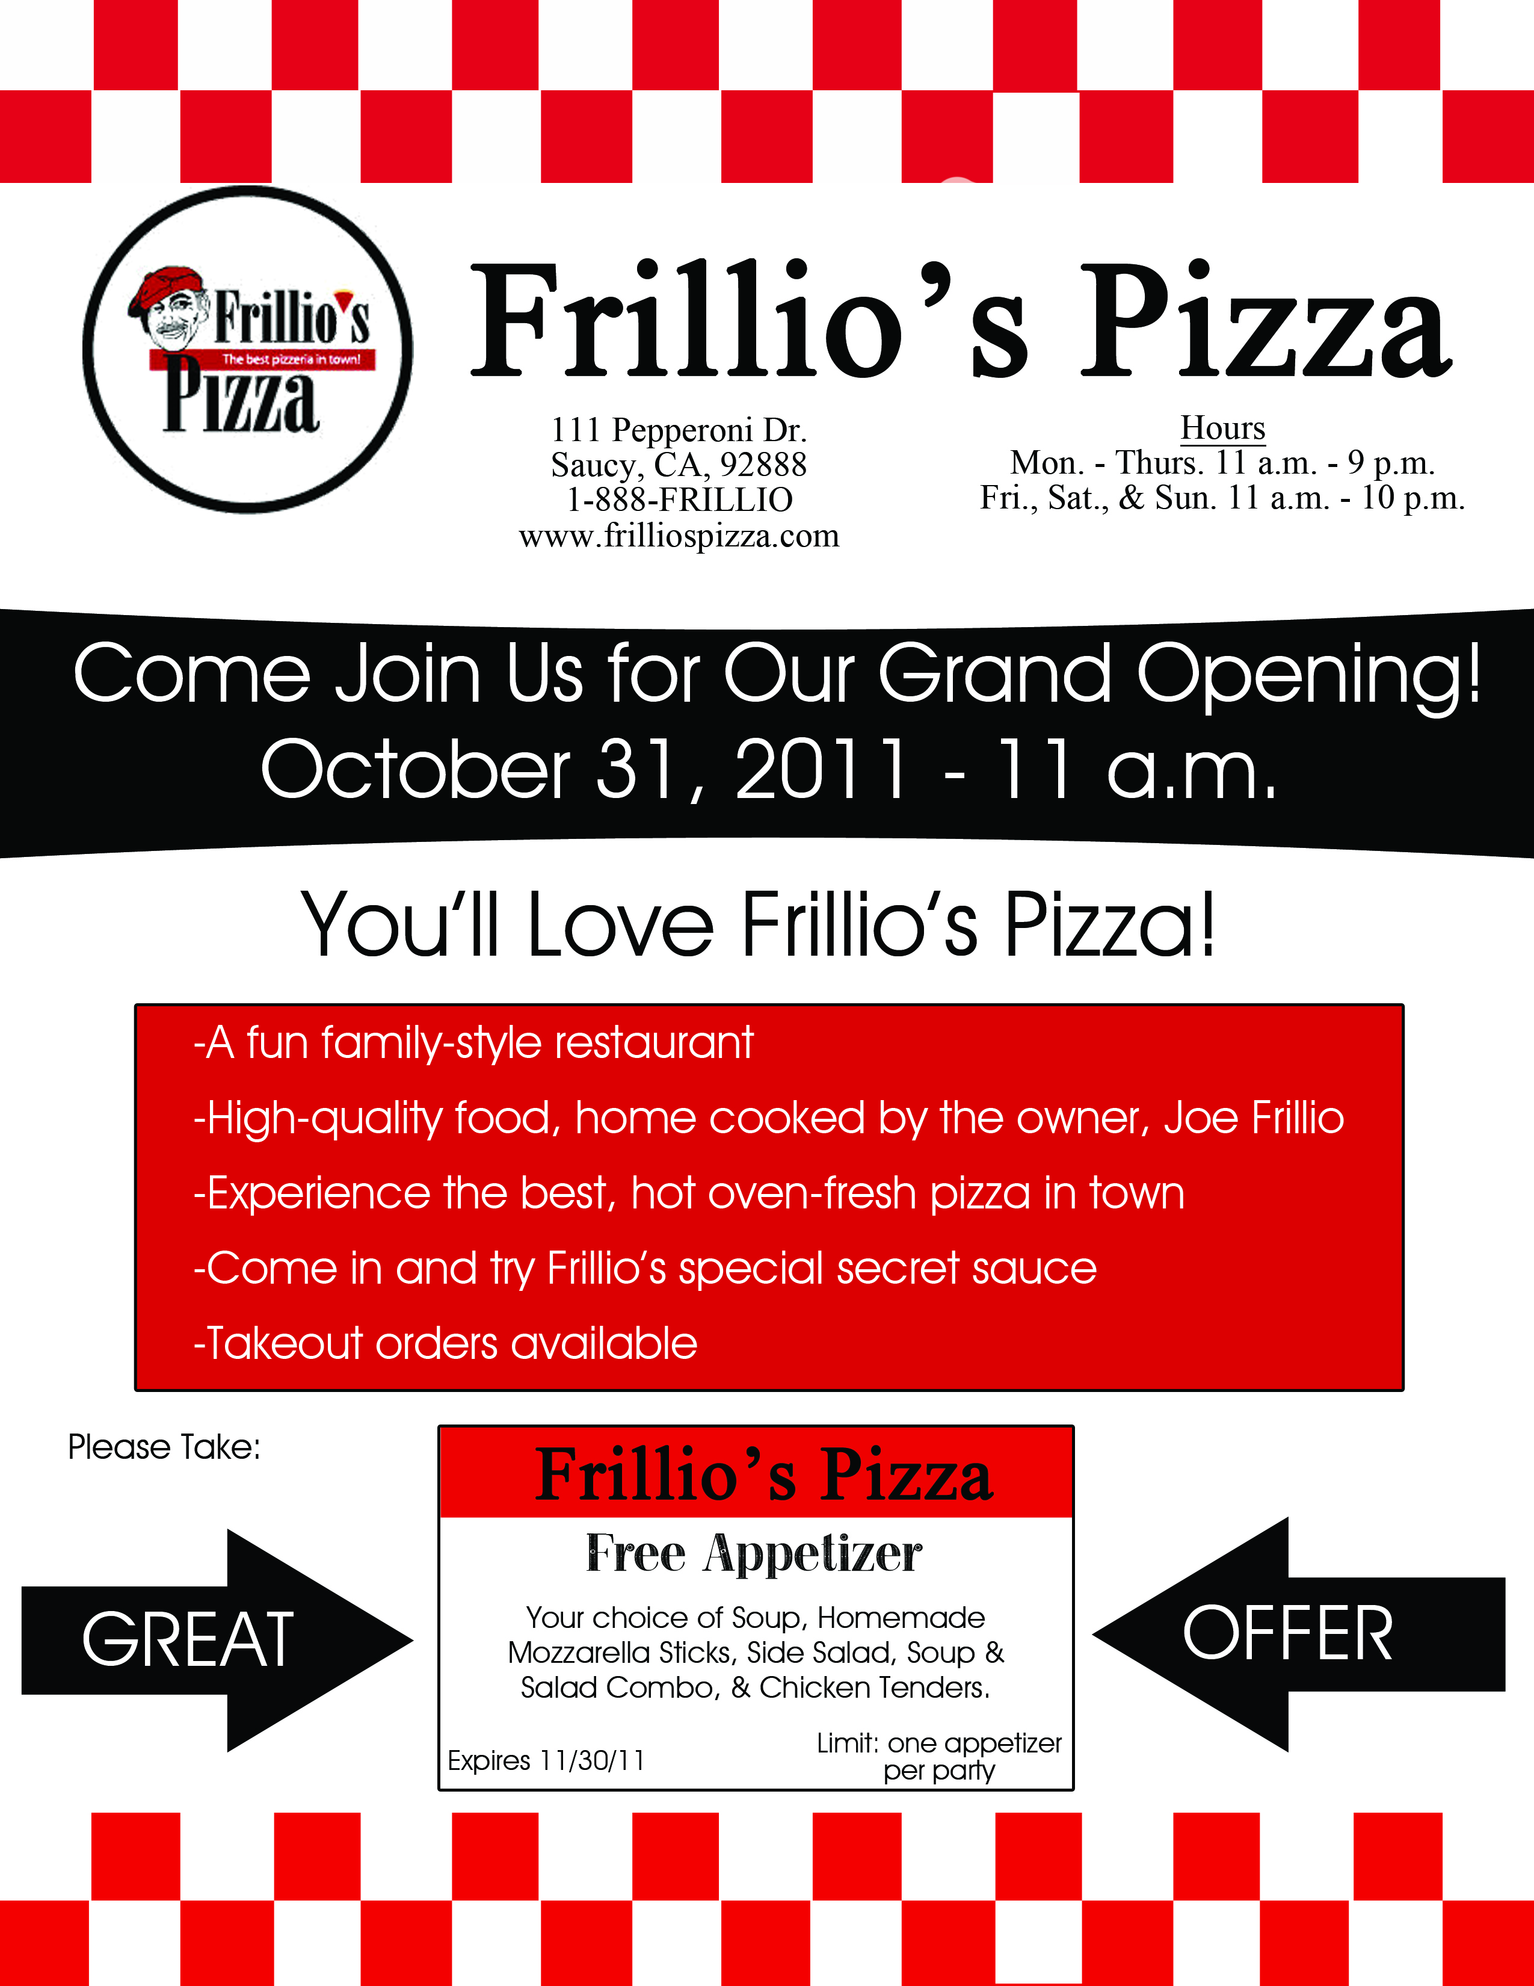
Radio Advertisement – 20 second radio ad
Directions: You will be running a commercial on the local radio station of your choosing. You will need to create a script for your ad that would run for 20 seconds. Your script could include one person speaking or even a dialogue between two or more people. Include any background or other audio description. Please label who is speaking in your script. Additionally, you will need to determine which radio station you will choose, and what times of the day your commercial will run. You will assume that you will run your commercial for the first 2 weeks of your business’s grand opening.
Radio station(s) that will broadcast your ad: _________________________________________________
Times of the day which your ad will run: ____________________________________________________
_____________________________________________________________________________________
EXAMPLE
(Electronic can opener sound and dog happily barking in background)
Spokesperson: Today, we’re going to be doing a simple taste test.
(Dog food being poured into a bowl)
SPOKESPERSON: Savory Chunks brand dog food versus the leading brand. Savory Chunks has a thick, hearty gravy. Let’s see how it tastes.
(Dog makes slurp sound licking his lips)
Script:
______________________________________________________________________________________________________________________________________________________________________________________________________________________________________________________________________________________________________________________________________________________________________________________________________________________________________________________________________________________________________________________________
______________________________________________________________________________________________________________________________________________________________________________________________________________________________________________________________________________________________________________________________________________________________________________________________________________________________________________________________________________________________________________________________
____________________________________________________________________________________________________________________________________________________________________________________________________________________________________________________________________________________________________________________________________________________
_____________________________________________________________________________________
Television Advertisement –30 second ad
Directions: You will be running a 30 second television ad. You need to create a detailed script for the ad which will include dialogue, descriptions of physical actions, as well as determine the station, and times of the day. You will assume that you will run this commercial for the first 2 weeks of your business.
TV station(s) that will broadcast your ad: ___________________________________________________
Times of the day which your ad will run: ____________________________________________________
_____________________________________________________________________________________
SAMPLE
DIALOGUE/AUDIO | ACTIONS
Hale Green: Hi. I’m Hale Green here to introduce Green Furniture’s Grand Opening! Come on inside and see what we’ve got! … | Mr Green walks out of the main entrance while speaking and points to grand opening sign so that the store sign and entrance are visible to camera. …

DIALOGUE/AUDIO | ACTIONS

(Continued on next page)

DIALOGUE/AUDIO CONTINUED | ACTIONS CONTINUED

