An investment is an asset an investor buys in hopes of it being worth more in the future.
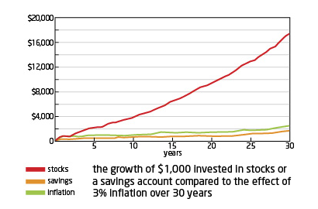
What are investments in our own lives?
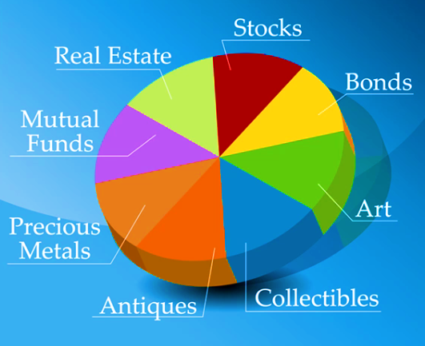

Why should you consider investing?
- In order to build your wealth at rates that will exceed inflation which is the rise in the level of prices over time.

The growth of the average U.S. stock has a return of 10% per year. A return is an annual rate of growth
Purchasing power the amount of goods (aka investments) you can buy with your money.
Stock is a share of ownership in the assets and earnings of a company
When a company would like to grow, it issues stocks to raise funds and pay for ongoing business expenses
Bond is a type of debt that a company issues to investors for a specified amount of time.
Stock market is a general term used to describe all transactions involving the buying and selling of stocks and bonds issued by a company
9 stock industry sectors:
- Entertainment
- Capital Goods
- Communication
- Consumer Goods
- Energy
- Financial
- Health Care
- Technology
- Transportation

Growth Investor: Growth investors buy investments that will increase in value over time- selling the investments later for a higher price.
Income Investor: Income investors buy investments that provide regular cash payments.
The dividend rate is the amount a company pays to its investors per share on a quarterly basis.
Why should a business consider going public?
- Businesses start small as a private business
- Private businesses may decide to “go public” and offer stocks for sale to raise money for making new products or expansion.
- Businesses will divide the ownership up into pieces (shares of stock) and offer these for sale.
When a business first offers stock for sale it is called initial public offering (IPO).
- The price of a stock is based on the total value of all assets of the business (cash, buildings, machines, and property) divided by the number of stocks.
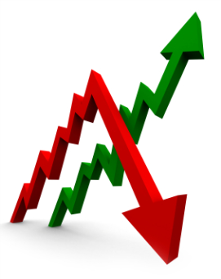
- Example: If a business had $1 million in assets and offered 500,000 shares for sale, each share would be worth $2.00
- $1,000,000/500,000 = $2.00
If investors want to buy stock in a company, the demand for that stock increases and the price will increase
If not as many investors are interested in a company, that lowers the demand for that stock and the price will decrease
A company’s stock price can be affected by conditions that have nothing to do with the business.

Conditions that affect stock prices:
- Economy
- Wars
- Natural disasters
- Political
- Publicity
- Employment

Sole Proprietorship is a business owned and operated by one person.
  - No stocks available

A partnership is owned by two or more people who are co-owners of a business.
  - Expenses and profits are shared amongst the partners.
  - No stocks available
Corporations are owned by people (stockholders) who own stock in the business. Corporations sell stock to raise money to make more products or expand.

There are two major exchanges where most stocks are traded at
  - New York Stock Exchange (NYSE)
  - National Association of Security Dealers Automated Quotation (NASDAQ)

NYSE: (New York Stock Exchange)
- Stocks traded on this market are usually well established companies.
- Includes blue chip firms and industrials that have been around for a long time.
- These stocks are considered to be more stable.
- All trades take place in a physical place—the trading floor of the NYSE.

NASDAQ: (National Association of Security Dealers Automated Quotations)
- Stocks traded on this market are usually companies that deal with high-tech, the internet and electronics.
- You will find new companies, start-ups here that are focused on growth rather than companies that have existed a long time.
- Can be unpredictable and unstable at times.
- Trading takes place on a telecommunications network—not in a physical place

An index is a method of measuring a SECTION of the stock market via a listing.
The two major indexes are:
- The Dow Jones Industrial Average
  - An average of 30 different companies that are major players within their industry.
  - Many of these companies are traded on the NYSE, with a few on the NASDAQ.
  - The Dow is used to give an idea of how the OVERALL stock market is performing.
  - Examples of companies under the Dow Jones include: Exxon Mobil, AT&T, General Motors, McDonalds Corporation, Coca-Cola, Home Depot, Wal-Mart, Pfizer, etc

- The S&P 500. (Standard & Poor)
  - It is another benchmark to indicate how the overall stock market is performing.
  - Many analysts use this average instead of the Dow Jones average because the
  - S&P 500 includes 500 companies rather than 30.
  - Examples of companies used in the S&P 500 include Amazon, Abercrombie & Fitch, Bank of America, Bristol-Myer Squibb, Sherwin Williams, Pepsico, Gillette, etc.
  - Standard & Poor’s is a company that does a great deal of research for companies and provide investors with financial information and opinions when making a stock choice.

