Mutual Funds:
Opening Storyline
- Let's suppose that you have $500 to invest in the stock market. However, you are concerned that you might lose too much of your money if you put it all in the stock of one company. So, you decide that you would like to spread your investment into several companies. In other words, you want to diversify your investment.
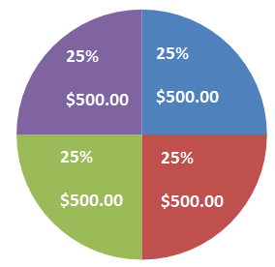
- To diversify your investments, you have to put your money in the shares of companies in different sectors so that if the shares of one company you invest in go down, other companies whose shares you are holding may be able to make up for this decrease if they go up in value.
- Because $500 is not really enough money with which to diversify your investment, you find three other friends who have $500 each and pool your combined $2,000. With the $2,000, you purchase about $500 worth of stock in 4 different companies in different sectors, such as the medical, financial, technology and transportation.
- Each of the four people who contributed to the pool of $2,000 owns 1/4th or 25% of the investments you have made. This means that each person owns 25% of the dividends and 25% of the value of the stock).
- Eventually when the investments are sold (liquidated), each person who contributed gets 25% of the profits. The collective investment you have made with the $2,000 pool of cash is actually called a mutual fund.
- Mutual funds are investments that pool money from many investors and invest it in a set of stocks or bonds.
- If one stock does poorly, the loss can be offset by the gains in other stocks within the mutual fund
- A mutual fund can contain stocks of over 100 companies in separate industries.
- Mutual funds are easy to buy and sell
- You can select from thousands of mutual funds
- Research the fund to see how it has performed over time
- Is the fund too risky?

- Mutual funds tend to have a slow but steady growth
- Mutual funds are generally less expensive than regular stocks
- Since mutual funds are a combination of many sectors, they generally have a lower risk factor
- If one sector performs lower, the remaining sectors will help to keep the value maintained.
- Mutual funds can be sold on any day the stock market is open. You can receive the money in your hands in just a few days to cover emergencies, etc.
- The owner (fund manager) of the mutual fund will send information to you regularly to keep you aware of any changes or growth in the fund. The reports will break down the performance into each sector that the fund is made up of
- The fund has a board of directors to manage the activity
- Decisions are voted on by you and other investors. If you do not like the way the fund is being managed talk with your vote.
Bonds:
- Sometimes businesses and the government need money (a loan) for different reasons:
  - They’re in debt
  - Need financial growth

- Businesses will borrow money from consumers (us) by selling bonds. This is no different than when we need to borrow money to purchase a big ticket item such as a car.
- Bonds are issued by corporations and governments when they need to borrow large amounts of money
- A government bond is a treasury bond, whereas a bond that a company sells is a corporate bond
- A bond is a certificate issued by the government or company in which it promises to pay back the borrowed money by a specified date with interest.
- When you buy a bond, the initial money you pay for it is called principal. The government (or corporation) then agrees to pay you back your principal with interest added
- The bondholder earns a fixed interest rate on a regular basis. This is the coupon rate.
- They agree that on a certain date, known as the maturity date, to pay your principal back. The further away the maturity date, the higher interest rate you will be paid
- Face Value is the amount printed on the certificate that must be repaid at the maturity date.
- Maturity date is the date the bond matures and principal with interest is repaid to the bondholder.
Example of buying a bond:
- When you purchase a bond, you pay half the price (half the face value). Let’s say you bought a $100 face value bond (you only pay $50)
- You will need to hold onto the bond for several years (usually 20) to get $50 back, plus an additional $50 in interest once it matures up to its face value of $100
Redeeming a bond:
- If you redeem your bond before the maturity date, you will be faced with a 3-month interest penalty
- If you buy your bond from the U.S. Government, you are guaranteed to be repaid
- U.S. Treasury bonds are considered the safest bond

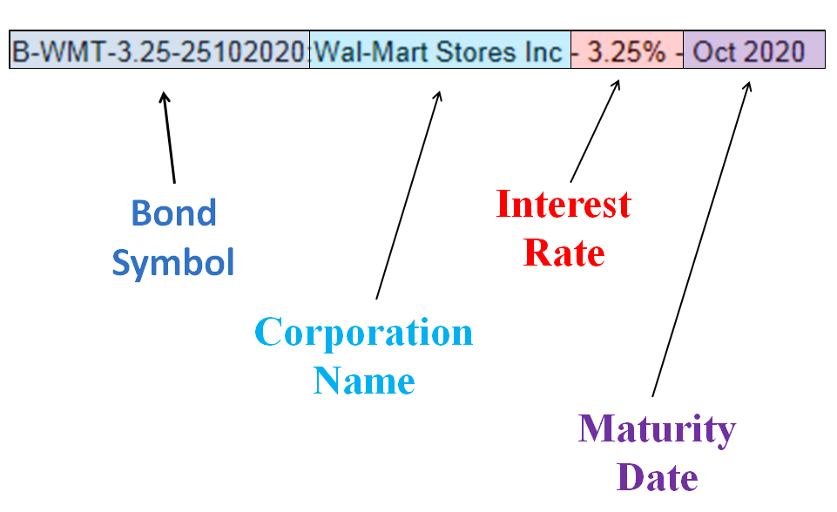
Reading a bond quote:

Risk:
No one can predict what the future holds. You invest money with the hope of high returns in the future; however, there are certain risks involved in investing that can alter the outcome of an investment. What Are Risk and Return?
- Risk is the uncertainty about the future benefits from an investment.

- For example, let’s say that you invest in a particular company by buying a few of its shares. The company performs extremely well one year, causing a rise in your initial investment. However, the following year the company faces a loss, causing a reduction in your initial investment. This unexpected loss is the risk involved in investing in a company.

Diversifying reduces the risk of losing all your money if an investment fails, which is the idea behind the old saying “don’t put all your eggs in one basket.”
