Name: ________________________________ Period: ______
Legal Process – Part 1
- Who is present in a courtroom?

- Types of trial courts:
Criminal Court
Probate Court
Juvenile Court
Small Claims Court
Civil Court

- Judge:

- Plaintiff:

- Defendant

- Bailiff:

- Court Clerk:

- Court reporter:

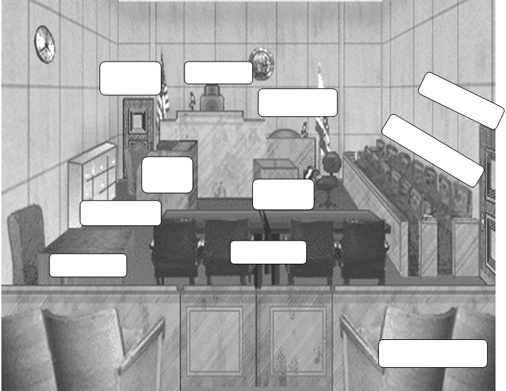
- Court interpreter:
Directions: Label the parts of the court room below. (Bonus credit [+3] for those who color)

