Name: _____________________________________ Period: _______

**Lesson 10-1**

**Journalizing Sales on Account Using a Sales Journal**

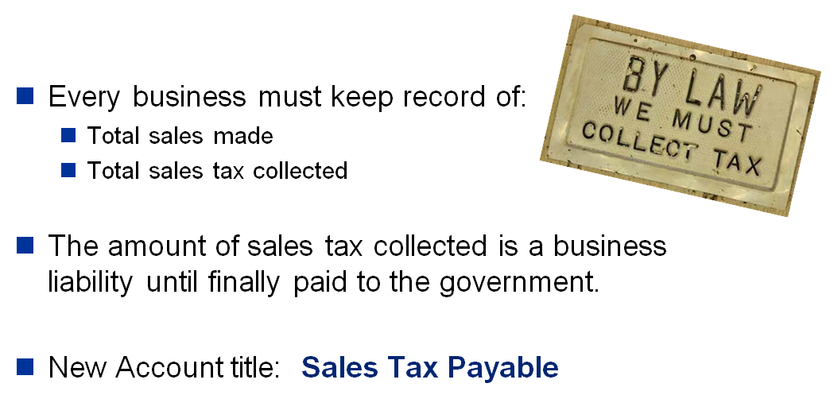

*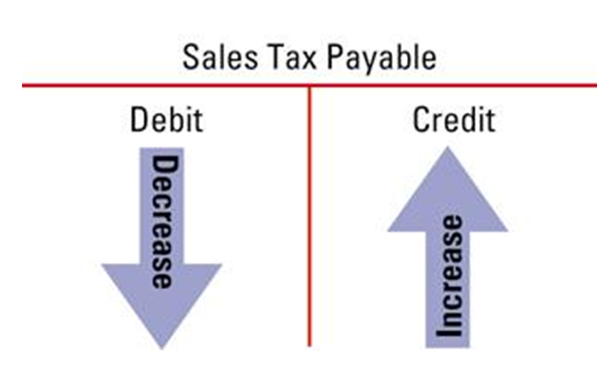(Draw arrows below to represent the increase and decrease to Sales Tax Payable)*

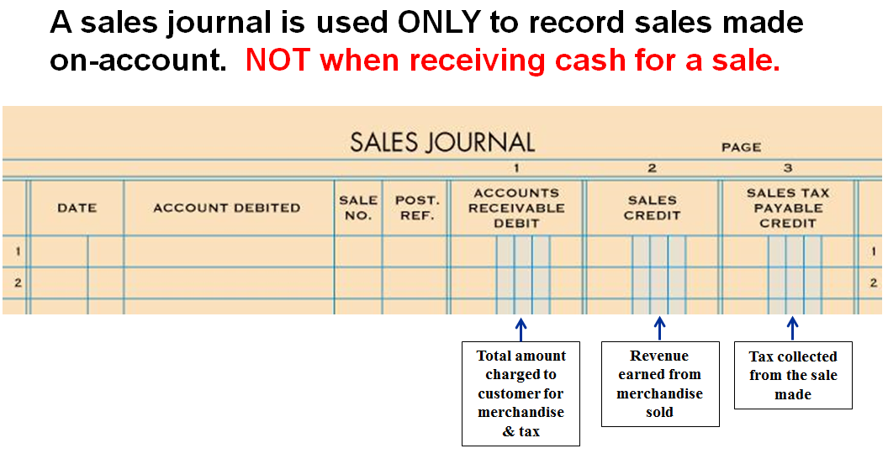

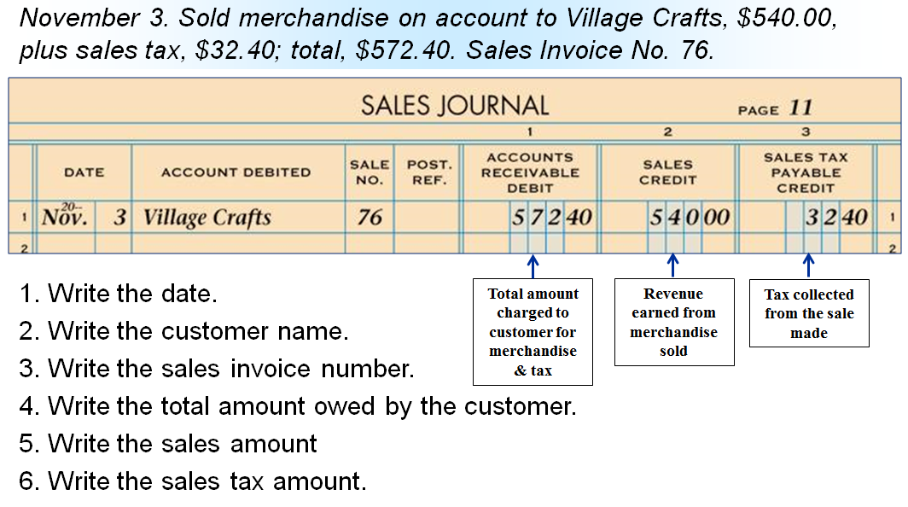

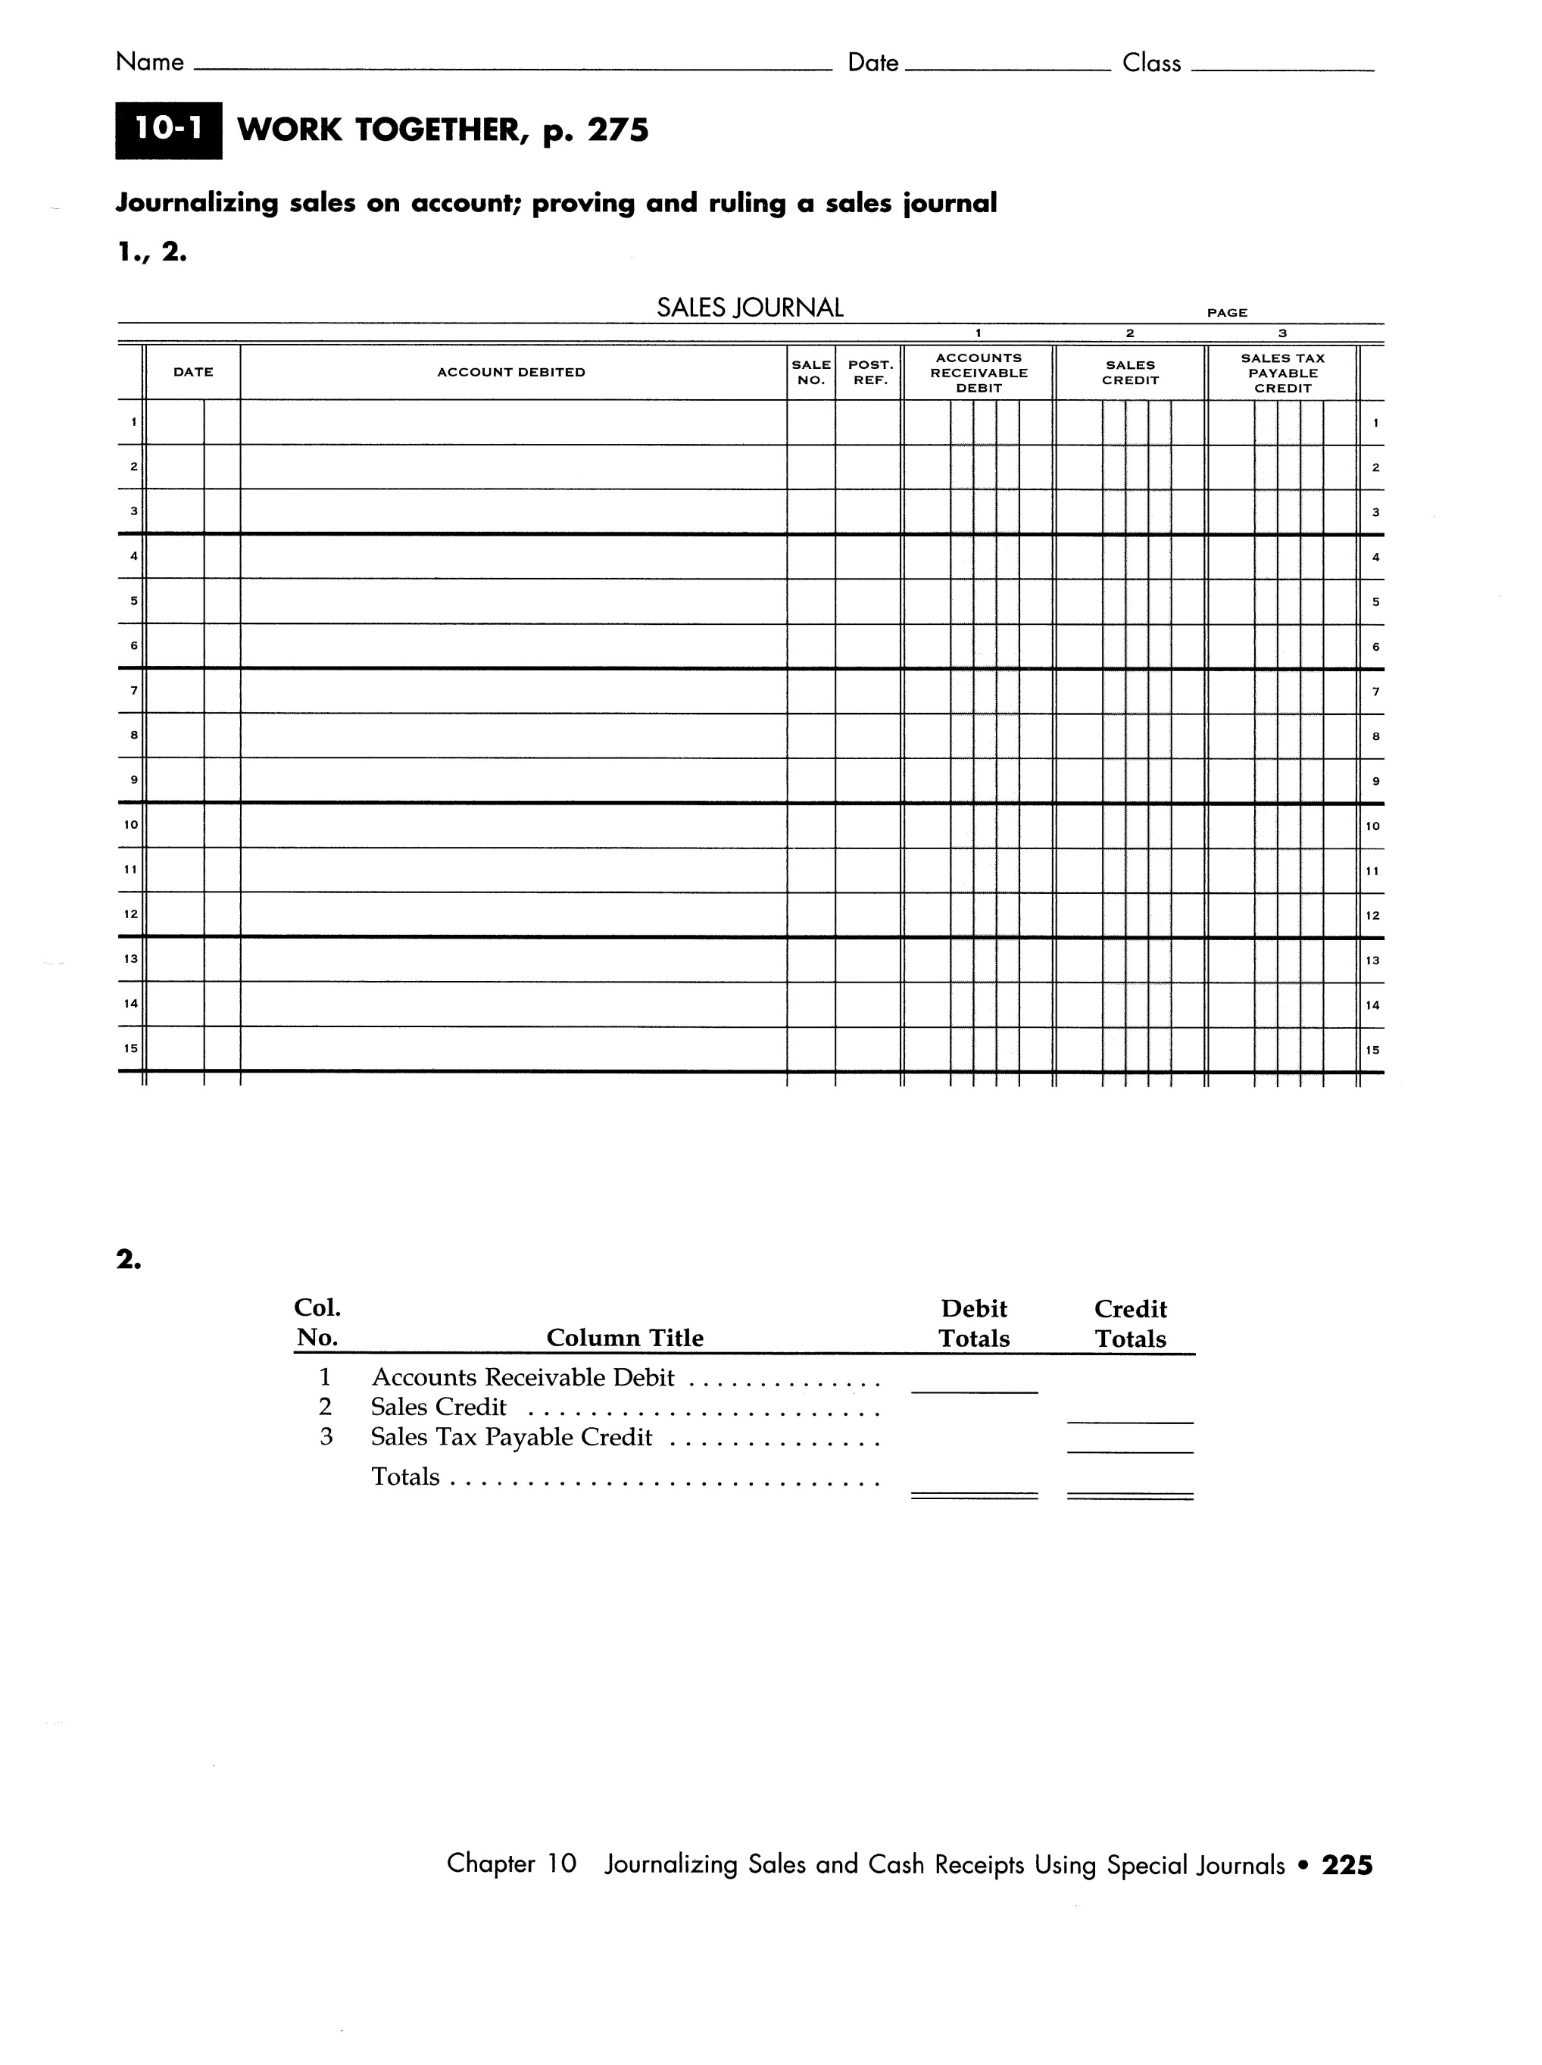

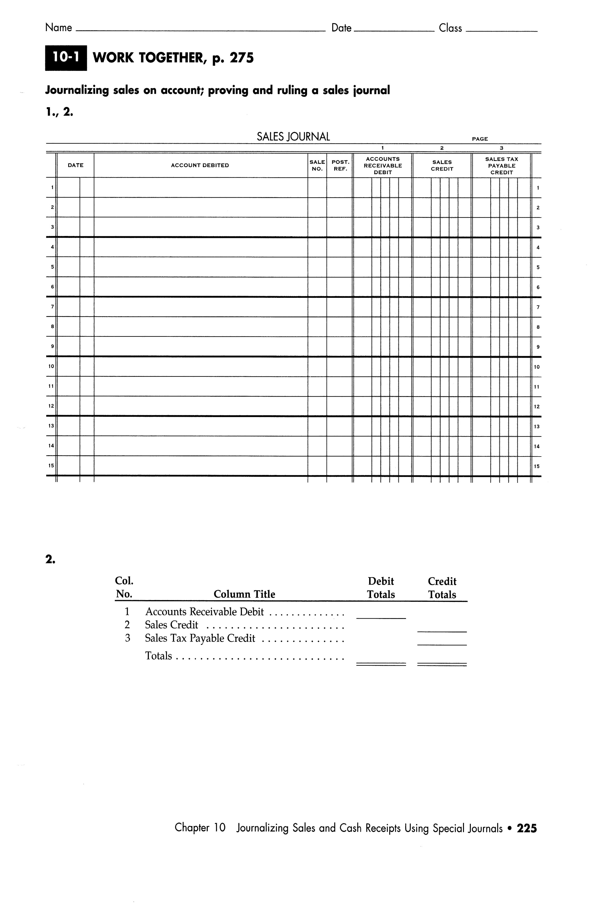

(10-1 On Your Own on next page)

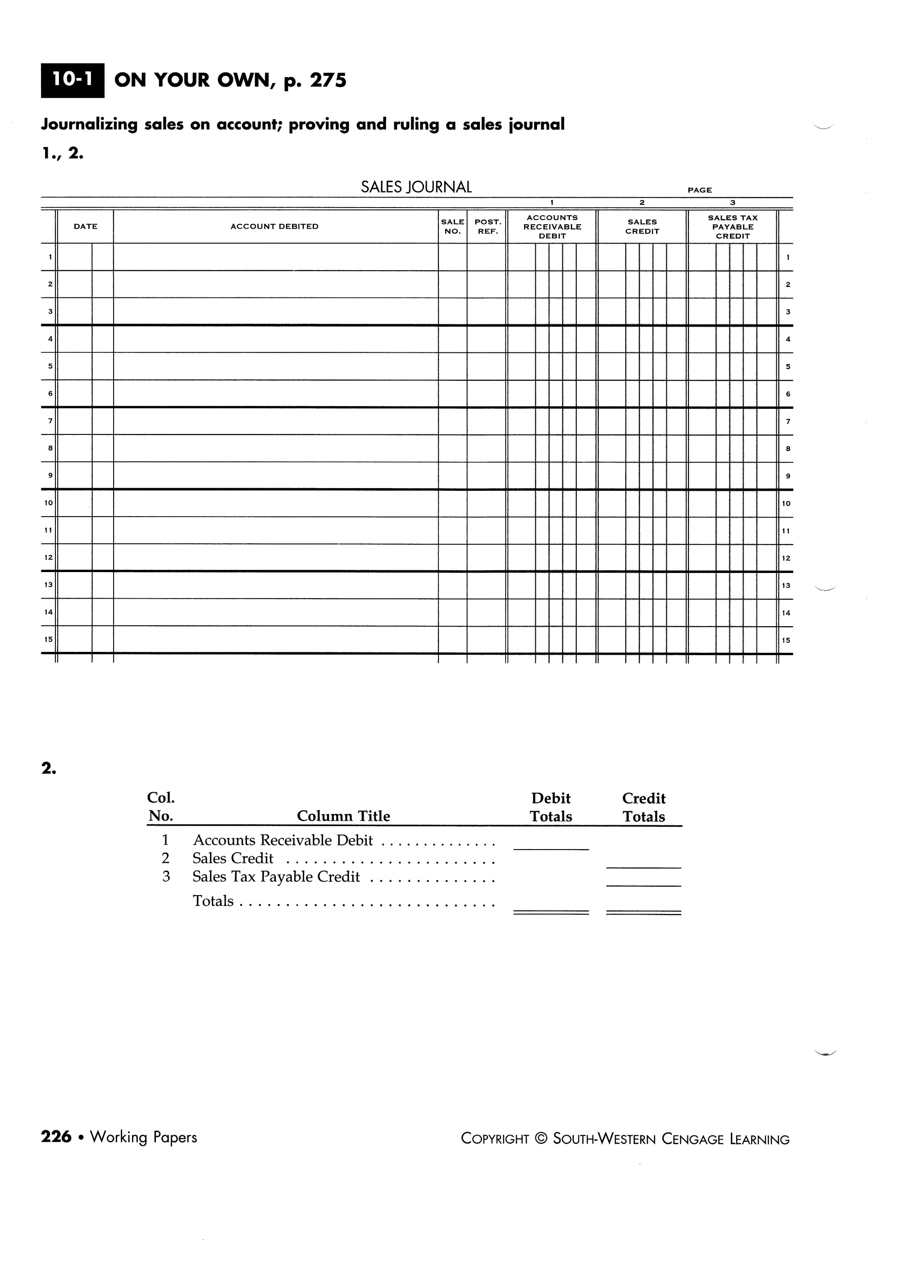

14 points

