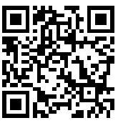Name: ____________________________________ Period: _____

**Lesson 10-2**

**Journalizing Cash Receipts Using a Cash Receipts Journal**

