Name: ____________________________________ Period: ______

**Lesson 10-3**

**Recording Transactions Using a General Journal**

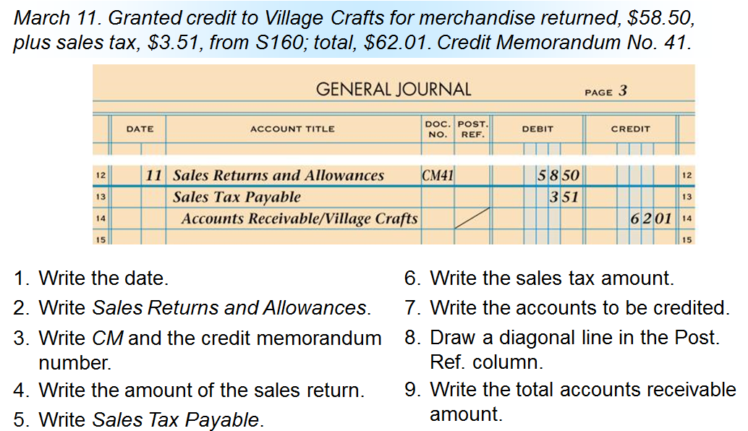

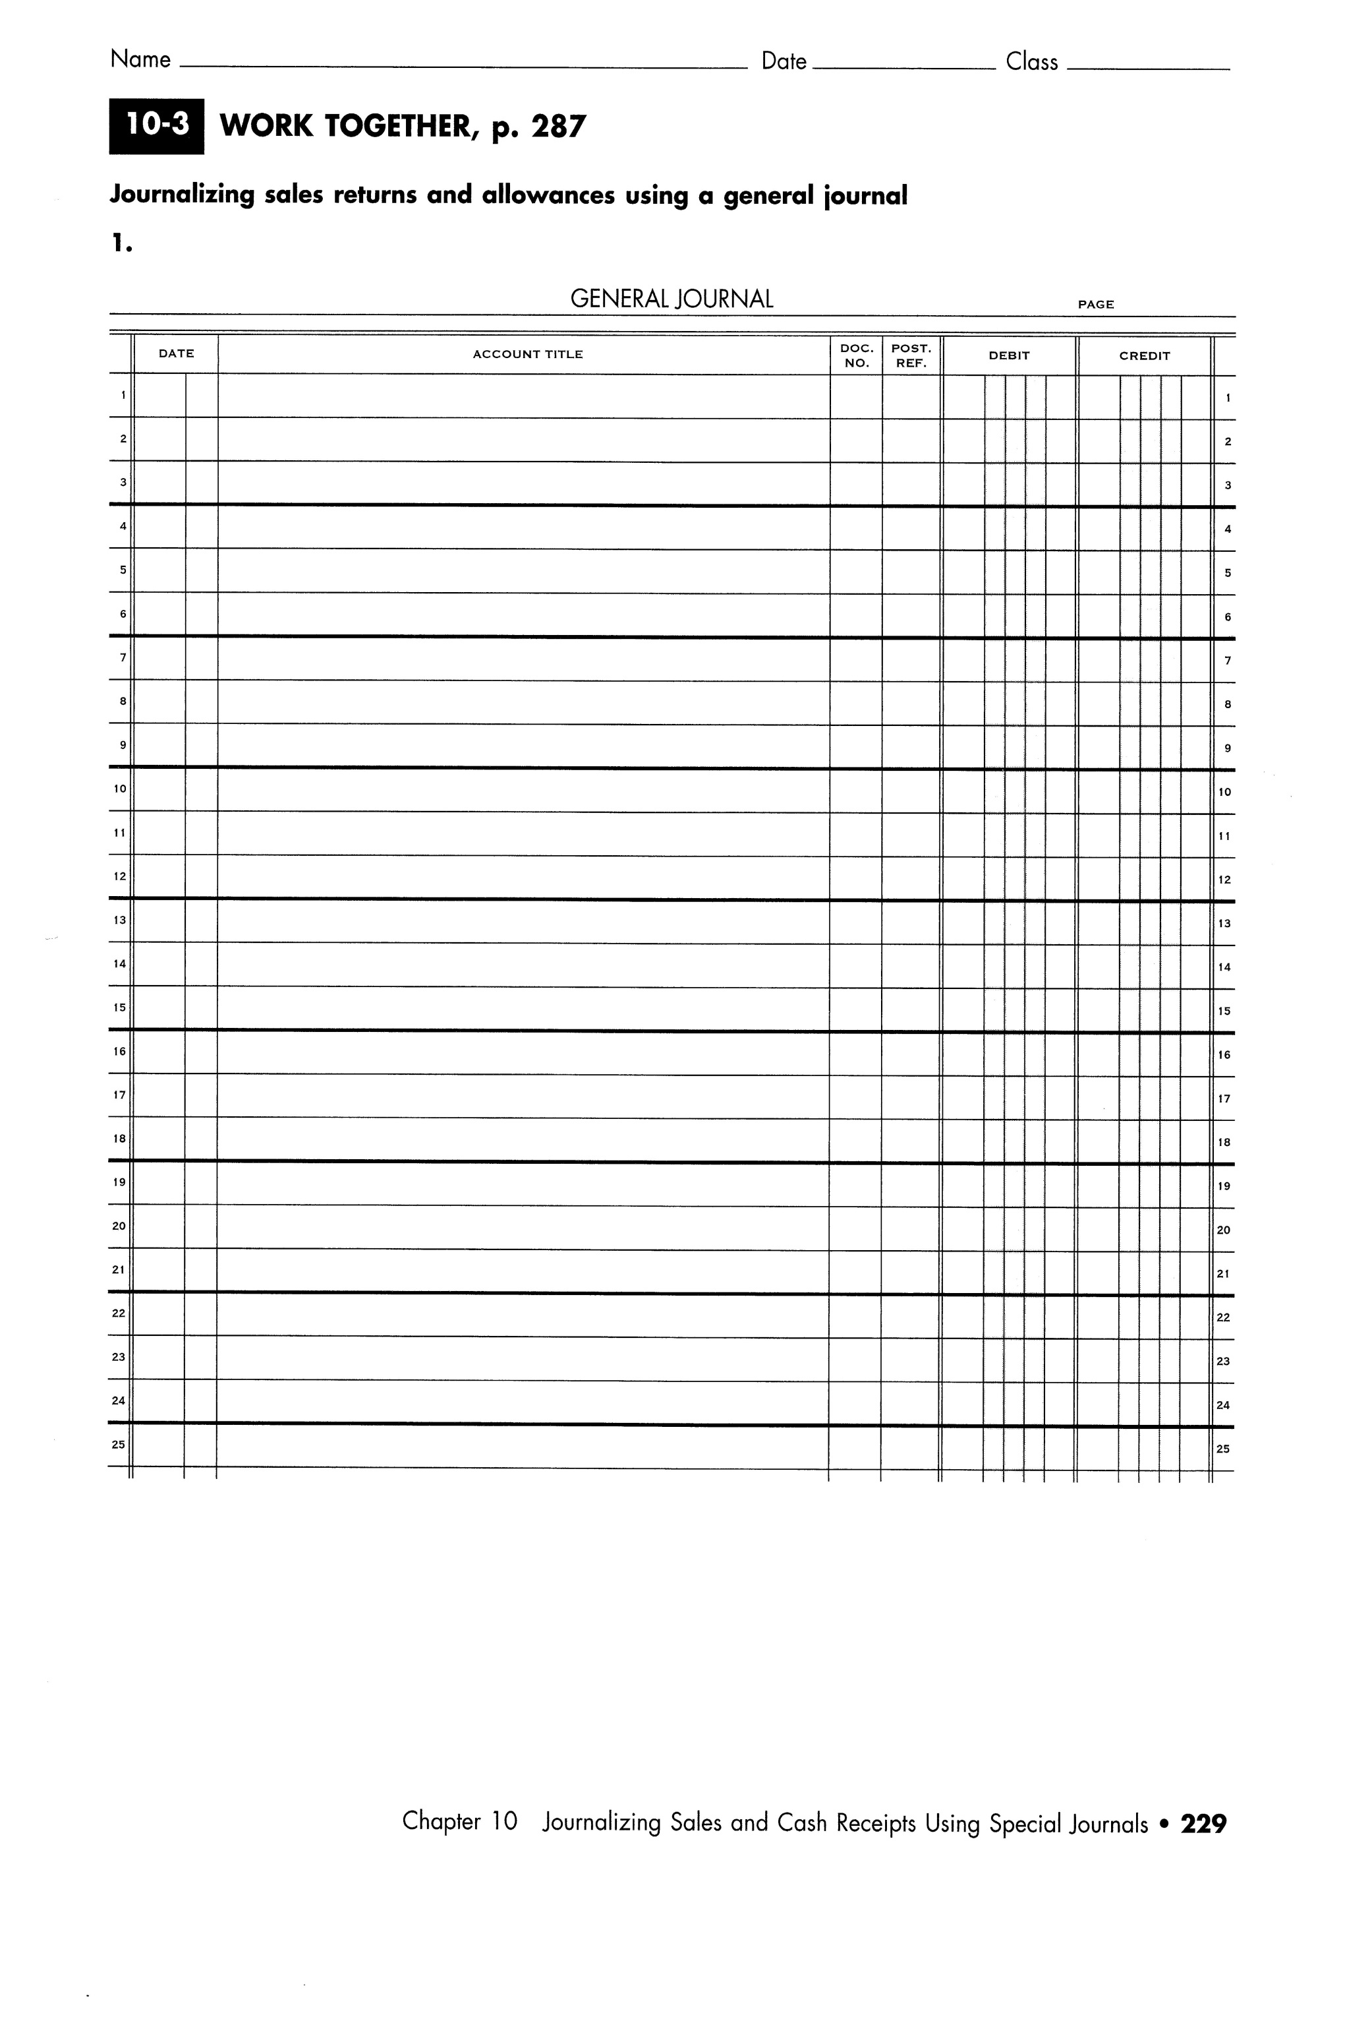

*(10-3 Application Problem on back)*

