Name: ________________________________________ Period: _____
Lesson 12-1: Preparing Payroll Time Cards
- ___________________ is the money paid for each employee’s service.
- A _______________ __________________________ is the time period covered by a salary payment. (ie. 3/22 – 4/11)
- _________________ is the total amount earned by all employees for a pay period.
- __________________ ______________________ is the total payroll earned for a pay period prior to tax deductions.

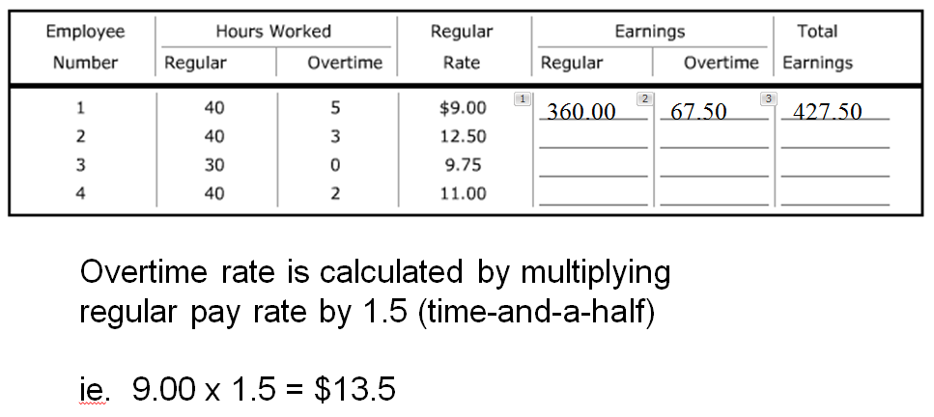

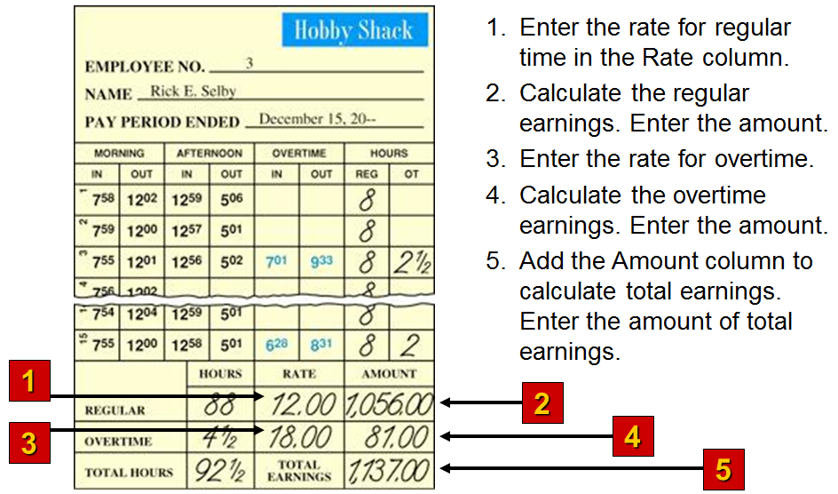

Class example completed together.

12-1 Application Problem, p. 360

