Name: ____________________________________ Period: _____
Lesson 12-2: Determining Federal Payroll Tax Withholding
- A ______ _________ alerts the employer as to how much federal tax to withhold from each employee’s paycheck.
- Your employer will provide you with the form once you are hired
- A W-4 must be completed by every _________ __________________
- Once hired, a W-4 does not need to be resubmitted or updated unless there’s a change to:
  - __________________ __________________
  - Number of _____________________
  - Exemption of earnings
- An ________________ is an exemption that determines how much tax to withhold from an employee’s paycheck
  - The more allowances, _______ ___________ is withheld
  - The fewer allowances, __________ _________ is withheld
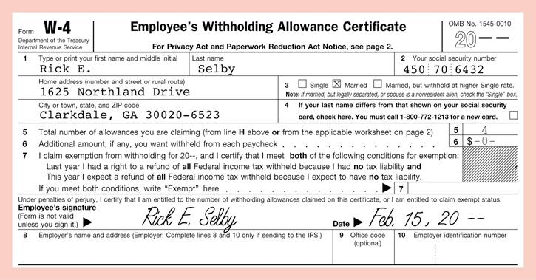
- Most full-time students younger than the age of ____ and the age of ____ are able to be claimed by a parent/guardian on their income taxes.

- To be ___________________ from having federal taxes withheld from your paycheck, you must meet several criteria:
  - You had the right to a full refund last year and had no tax liability
  - You anticipate on having a full refund this year
  - You’re ________ _______ ________ claimed as a dependent
  - You will not earn more than $_____________ for the year
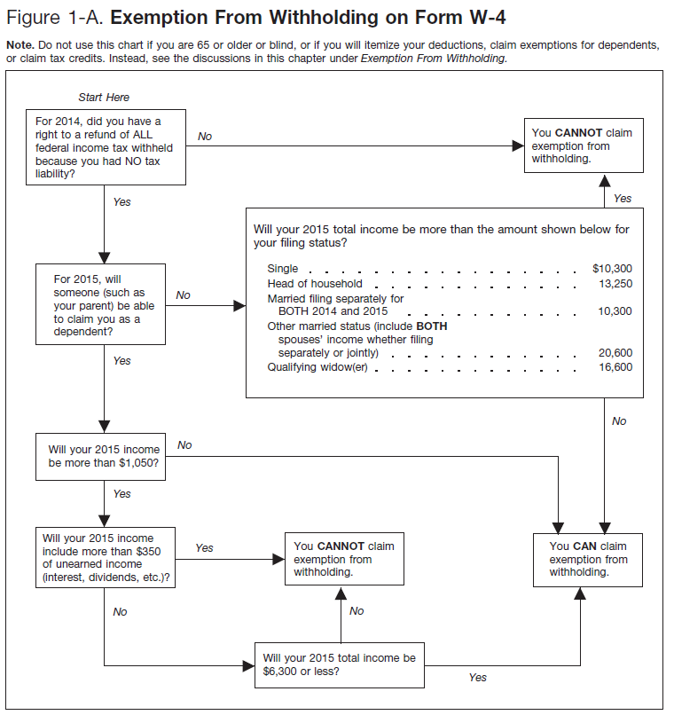

- Sarah is 17 years old, and was just hired for her first job. She is a senior in high school. She plans to work about 15 hours each week after school earning about $121 per week. Can Sarah claim exemption on her W-4? Complete the following W-4 using Sarah’s information.
- Sarah H. Smith, 555 Main St., Springfield, OH 44123, Social Security: 123-45-6789
