Name: ___________**_________________________ Period: _______**

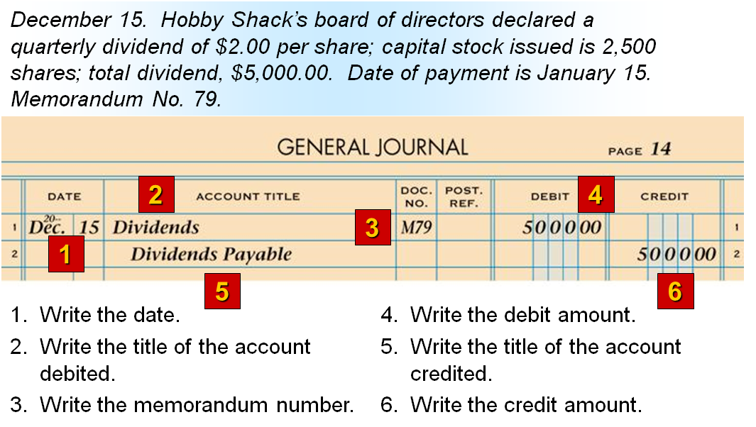**Lesson 14-1: Distributing Corporate Earnings to Shareholders**

