Name: _______________________________________ Period: ____
9-1: Journalizing Purchases Using a Purchases Journal
- A _____________________ business purchases goods to sell
- _______________________ is the goods that a business purchases to sell
- Types of merchandising business are:
- __________________ business (sells directly to customers who consume the merchandise)
- ________________________ business (sells retail directly to other businesses)
- A __________________________ is a business owned by just one owner
- A ______________________________ is owned by many persons
- A unit of ownership in a corporation is a share of ___________________.
- An owner of one or more shares of a corporation is a __________________________.
- A business who has a limited amount of transactions can record all transactions in one general ___________________.
- A business who has multiple transactions may choose to use a separate journal to record each type of transaction called a ___________________ journal
- Examples include
  - ____________________ journal
  - _______________ payments journal
  - _____________ journal
  - Cash _____________________ journal
  - _________________ Journal
- The price a business pays for goods it purchases is called the ____________ of _________________________
- In order to make a profit, a business must charge customers more money than it cost to purchase the merchandise, this is called a ________________________ price
- ________________________ includes the cost of merchandise and the markup price.

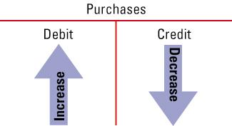
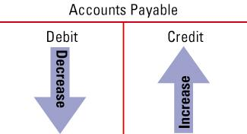

(Please illustrate increase and decreases by drawing arrows in the debit and credits above)
