Name: ___________________________________ Period: ______
9-2: Journalizing Cash Payments Using a Cash Payments Journal
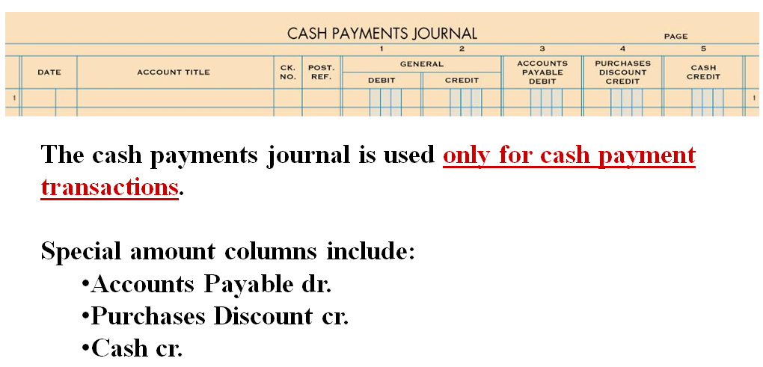
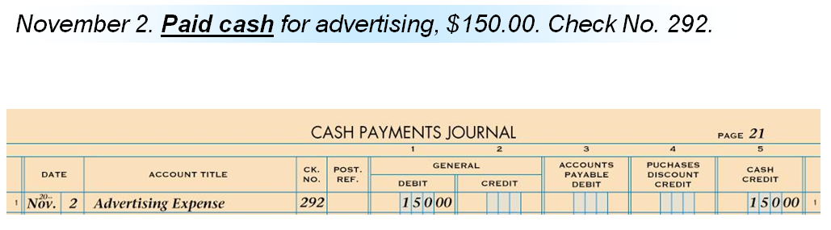

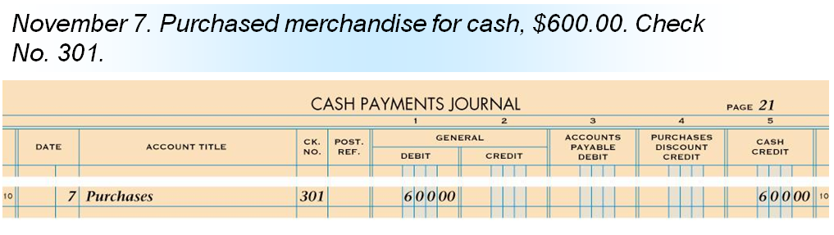
- To encourage early payment, a vendor may allow a cash discount on the invoice amount.
- A cash discount on purchases taken by a customer is a purchases discount. The customer pays less than the invoice amount.
- A reduction in the invoice list price granted to a customer is a trade discount.

