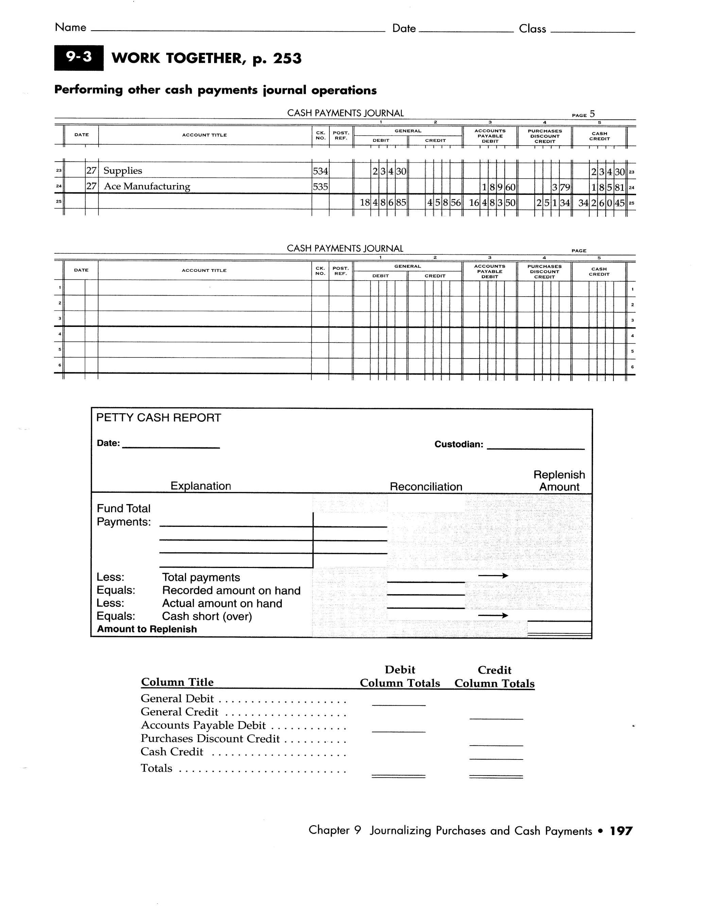Name: _____________________________________ Period: _____

