Name: _______________________________________ Period: _____
Mutual Fund Creativity
Directions: Create your own mutual fund by dividing the pie chart below into a diverse range of sectors of your choosing. You must decide how big (%) each sector will be and how much of your total mutual find each sector will represent.
Name of mutual fund: ________________________________________________________________
Mutual fund symbol: _____________________
Sectors which will be used to represent the different slices of your mutual fund (see your unit outline for information). Please list all nine sectors even if not being represented in the total make-up of your mutual fund. The percent make-up should total to 100% once all percents are listed.
Stock Sector Type | Percent Makeup of Mutual Fund

Use the pie chart below and divide it up into the nine stock industry sectors proportionately using the percentages that you outlined above. Label each stock industry sector that makes up your mutual fund.

List all of the stock industry sectors from the front that make up your mutual fund and all companies that make up that stock sector. Stock sectors with a larger percentage should have more companies that make up that particular stock sector.
Sector: _________________________________ | Sector: _________________________________
Sector: _________________________________ | Sector: _________________________________
Sector: _________________________________ | Sector: _________________________________
Sector: _________________________________ | Sector: _________________________________
Mr. Stasa’s Example
Mutual Fund Name: Stasa’s Winners Group Mutual Fund
Mutual Fund Symbol: STASWG
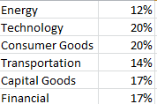

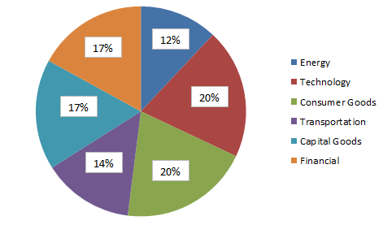

Energy  - Chesapeake Energy  - Helmirch & Payne Energy | Transportation  - Greenbrier Cos Inc.  - Trinity Industries Inc  - Aircastle Ltd
Capital Goods  - James Hardie Industries  - Elbit Systems Inc  - Agco Corp  - Toro Co. | Financial  - Wells Fargo  - CitiGroup  - JPMorgan Chase  - Bank of America
Technology  - Google  - Accenture  - Sapient  - Hackett Group  - Apple | Consumer Goods  - WD-40  - Clorox  - Proctor & Gamble  - Colgate  - Orchids Paper

