My Next Move Career Search

- Enter the following address into your web browser (preferably Google Chrome): http://www.mynextmove.org/explore/ip

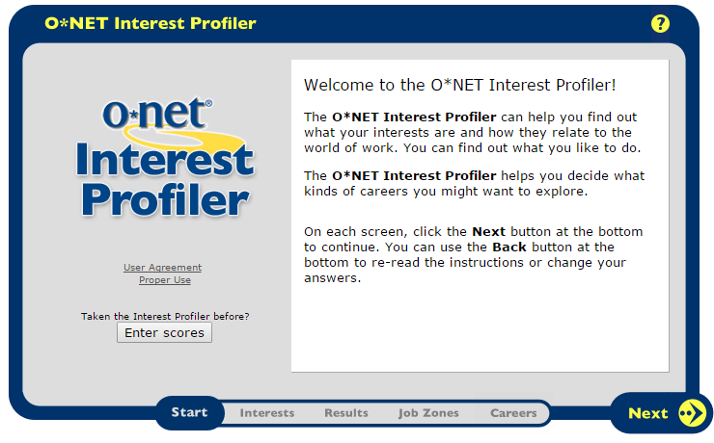
- Click the NEXT button four times (4x)

- Answer all 60 questions on the O*Net Interest Profiler as to whether you strongly like or strongly dislike each statement, making sure to click the NEXT button after each page has been fully complete.
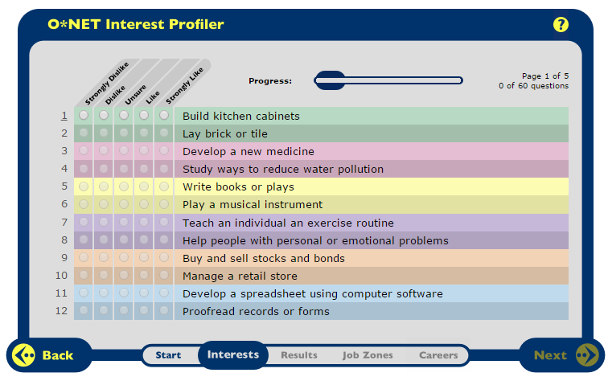

- Once you’ve answered all 60 questions you will be brought to a screen that says Great Job! You must press Next.

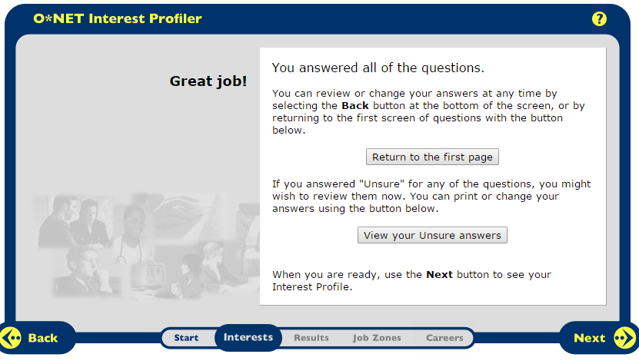

- You will then be brought to a page that will view your Interest Profiler results. Indicate your score for each category on the attached page for Part I.
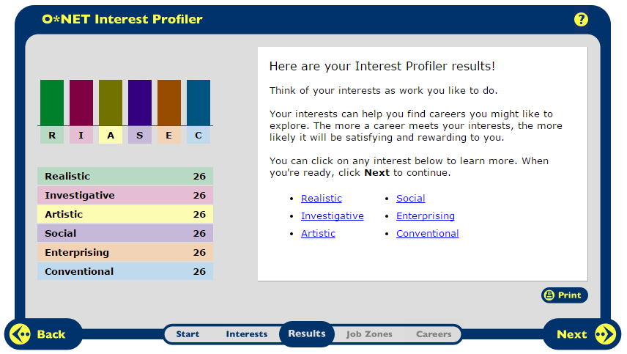

- You will then be brought to a page that explains interests, job zones, and careers. Please click Next and then click Next again.
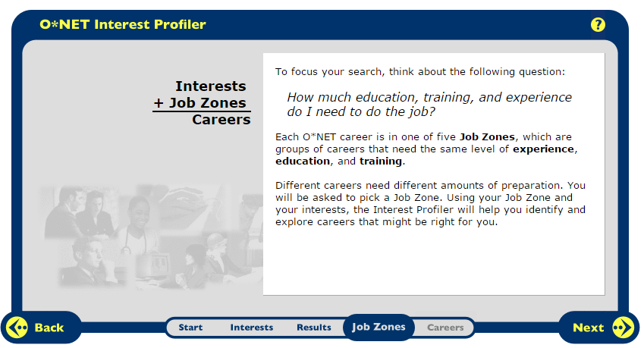

- This next page displays different levels of job preparation. Take a moment to click the links below to explore the level of preparation that will be required for different job types. Determine which job preparation level you would be most comfortable with on the attached page for Part II.

- The next section displays different job zone levels. Select the job zone level you are most comfortable with. Click Next and then click Next again.
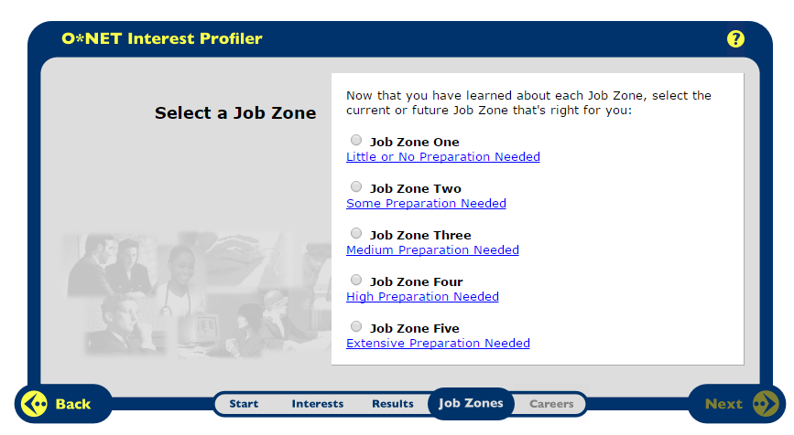

- You will now be provided with a list of many career choices that you can scroll through. Please select three careers that best suit your interests and list then on part III. You can click on each career to get a description.
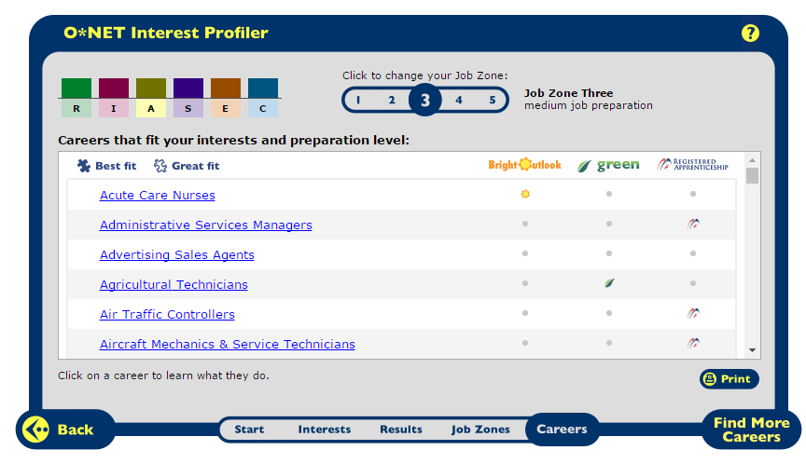

- Click on each of your top three career selections to view more detailed information. Enter a few portions of each career choice on the attached page for part IV.

