Name: __________________________________________ Period: ______
Monthly Bills Project Notes/Demos

A __________________ ____________ is a written form that states a written amount to withdraw directly from the payer’s account.

- A __________________ is a person to whom money is owed to (receiving)
- A ________________ is a person who pays money (giving)
- A _____________________ ________________________ is a nine digit magnetic code that identifies the financial institution that must pay funds. (the payer’s bank)
- A ______________ ________________________ ___________________ identifies the payer’s bank account.

LABEL AND FILL OUT THE CHECK BELOW USING THE EXAMPLE FROM THE POWERPOINT

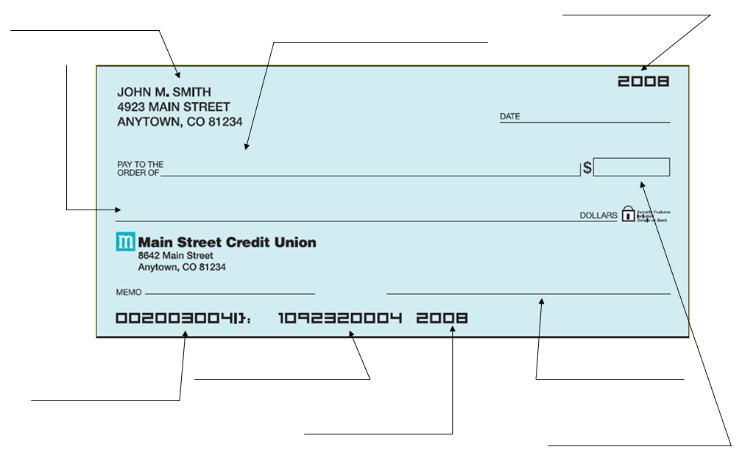

Please complete the following sample checkbook register using the PowerPoint in class.

(1) Opened a new checking account and made a opening deposit of $200.00 into account on Monday. No prior balance.
(2) Paid $20.00 for new checkbooks on Monday.
(3) Paid $23.11 for groceries at “Fine Foods” using check #100 on Tuesday.
(4) Withdrew $40.00 from your bank’s ATM on Thursday.
(5) Paid your cell phone bill online for $55.00 on Friday.

Transaction codes:
AD = Automatic Deposit
AP = Automatic Payment
ATM = Cash Withdrawal
DC = Debit Card, SC = Service Charge

