Name: ___________________________________ Period: ________

Planning Your Business Plan

Directions: You will be navigating the Entrepreneur website to learn how to prepare writing your business plan. Click on the link below to begin:

http://www.entrepreneur.com/businessplan/index.html
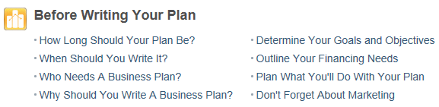

How Long Should Your Plan Be?

- How many pages of text should a business plan be in today’s standards? How many pages of appendices should you have?

- How many pages are too long for a business plan?

- What should the average font size be on a business plan?

- Words crammed together into small spaces should be avoided by doing what?

When Should You Write It?

- Who doesn’t need a business plan?

- Who is “the classic business plan writer?”

- Are business plans used only for those just starting-up a business?

Why Should You Write a Business Plan?

- Planning for the future: Whether plans today are long, short, elaborate or simple, they still contain the same basic elements they always have. What are these basic elements?

Determine Your Goals and Objectives

- Determine your objectives: To plan your plan, you'll first need to decide what your goals and objectives in business are. What are the four questions that are an important part of building a successful business plan?

- Goals and objectives checklist: What are three items on the checklist you feel are essential to have in your business plan?

Plan Your Plan:

- Do you intend to use your plan to help you raise money? What will you need to focus on very carefully?

- If you’re looking for a bank loan, what will you need to stress in your business plan?

