Name: ____________________________________ Period: ____

Small Business Administration Web Search

Directions: Enter the following address into your web browser and answer the following questions:

http://www.sba.gov

- Click the Starting & Managing tab on the website
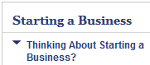

- Select Starting a Business
- Click Thinking About Starting a Business?

- Click the article Is Entrepreneurship For You?

- List the six characteristics and skills (the bolded terms only) commonly associated with successful entrepreneurs below:

1 | 2
3 | 4
5 | 6
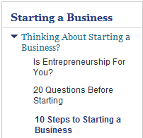
- Next click the 10 Steps to Starting a Business article
And list the 10 steps below:

Step 1: ________________________________________

Step 2: ________________________________________

Step 3: ________________________________________

Step 4: __________________________________________________________________

Step 5: __________________________________________________________________

Step 6: __________________________________________________________________

Step 7: __________________________________________________________________

Step 8: __________________________________________________________________

Step 9: __________________________________________________________________
(continued on next page)
Step 10: _________________________________________________________________

- Which of the 10 steps that you just listed do you feel grabbed your attention the most? Explain why.
________________________________________________________________________
________________________________________________________________________
________________________________________________________________________
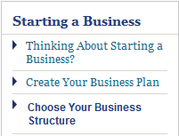
- Next click the Choose Your Business Structure article:

You have several options when it comes to your business
structure. You can run your business as a sole proprietorship,
limited liability, cooperative, corporation, partnership,
or S-corporation.

Browse through each of the six types of business structures and select the structure that you think will best fit your needs as an entrepreneur. Once you’ve selected your business structure, read about the advantages and disadvantages of your selection. Most students select sole proprietorship or partnership, but I have had all varieties. Explain why.

Selected business structure type: ____________________________________________

Advantages of this type of business structure (briefly list two):
- __________________________________________________________________
- __________________________________________________________________
Disadvantages of this type of business structure (briefly list two):
- __________________________________________________________________
- __________________________________________________________________

Explain why you selected this type of business structure, _________________________
________________________________________________________________________________________________________________________________________________________________________________________________________________________
- Continue exploring the Starting Your Business section on your own. Locate one more additional link/article that you find obtains to your interest. What did you find? Why did it interest you?
____________________________________________________________________________________________________________________________________________________________________________________________________________________________________________________________________________________________________________

