Table of Contents
SAMPLE ONLY (your page numbers may be different, but the order of titles should be the same)

Company Profile 1

Statement of Purpose 2

Executive Summary 3

History and Background 4

Goals and Objectives 5

Price List and Description 6

Location 7

Form of Ownership 8

Target Market 9

Product Advantages 10

Financial Statements 11

Business Risks 12

Total Capital Requested 13

Appendix

Floor Plan A1

Job Application A2

Job Descriptions A3

Employee Organization Chart A4
Table of Contents
Business Plan Project

- Make sure your page margins are set to 1” (top, left, bottom, right)
- Center and type the title “Table of Contents” on the top line.
- Press the [Enter] key three times after typing the title of the page
- Make sure the ruler is visible at the top of your screen. Select the View tab and make sure that Ruler is selected as seen below.
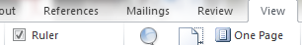

- Set a left tab at 6” (This can be done by left-clicking on the top ruler at that exact point. To remove a tab, simply click and drag the tab off the screen)
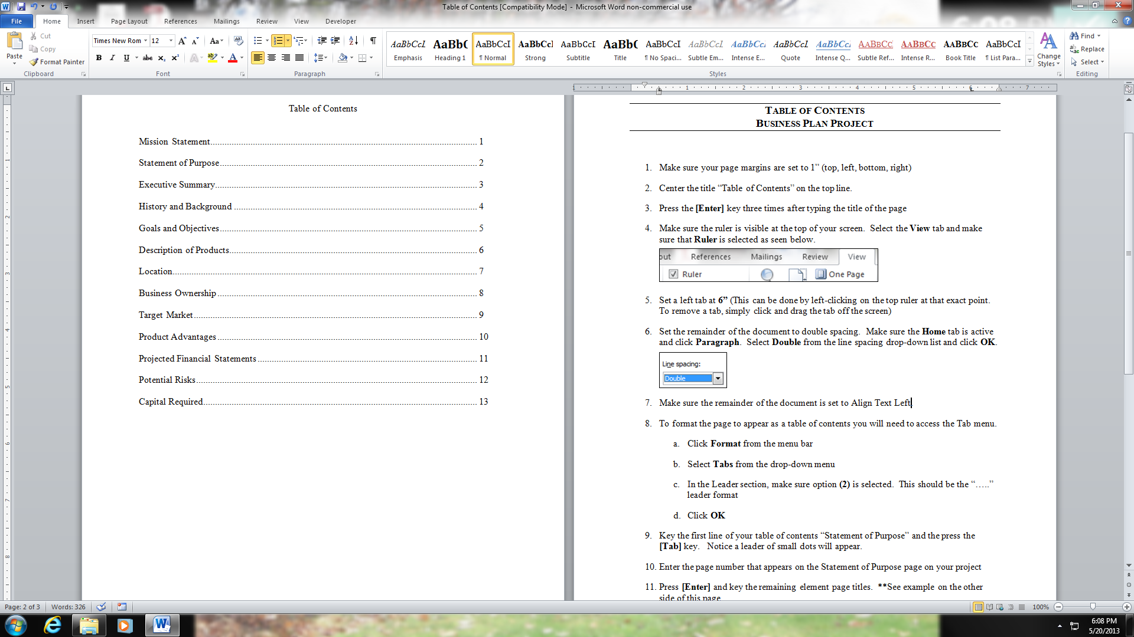
- Set the remainder of the document to double spacing. Make sure the Home tab is active and click Paragraph. Select Double from the line spacing drop-down list and click OK.
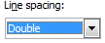
- Make sure the remainder of the document is set to Align Text Left.
- To format the page to appear as a table of contents you will need to access the Tab menu.
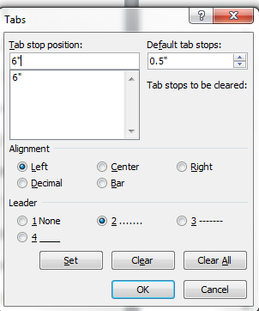
  - Click Paragraph from the Home tab.
  - Select Tabs at the bottom of the dialogue box.
  - In the Leader section, make sure option (2) is selected. This should be the “…..” leader format.
  - Make sure all settings match the image on the right. Click OK

(Continued on next page)
- Key the first line of your table of contents “Statement of Purpose” and the press the [Tab] key. Notice a leader of small dots will appear.
- Enter the page number that appears on the Statement of Purpose page.
- Press [Enter] and type the remaining page titles.

Note that the Cover Letter, Cover Sheet, and Table of Contents are not listed on the Table of Contents page.

Make sure all pages are in the correct order before stapling your business plan together and handing it in.

